

Higher Technological Institute

Faculty of Engineering

Mechatronics Department

**Engine Control Unit   
[ECU]**

Graduation Project Submitted By:

Omar Abdelghany Ahmed

Mohamed Yehia Shaaban

Donia Khaled Amer

Ahmed Ashraf Abdel-Aziz

Ali Tarek Abdel-hai El Hadidy

Omar Adel Ahmed Mohamed

Mohamed Mostafa Abdel-Mawgood

20160601

20160927

20160368

20160036

20160563

20160601

20160908

Under the supervision of

**Dr. Amal Ibrahim**

2021

# ACKNOWLEDGEMENT

Praise to ALLAH, All Mighty, by whose grace this work has been done.

Our gratitude goes to our project supervisor Dr. Amal Ibrahim.

We would like to express our very great appreciation to Technician Reda and the Whole crew for Supporting our project and providing us with the technical information.

We would like to offer our special thanks to each and every person who assisted us by putting their work and guidance on the internet in an open-source format including: ResearchGate.net, Lucas Sangoi Mendonça.

We wish to acknowledge every entity that made the components for the project available for purchase or provided us with guidance from where to buy them: Kitchen Maker Space, RAM Electronics, Free Electronics.

We are extremely grateful to our parents and families for their continuous love, prayers, sacrifice, care and support. This whole project would not have been possible without them.

# ABSTRACT

Modern automobiles are electrically controlled by means of electronic control units "ECUs" which consist of microprocessors or microcontrollers. Generally, these control units are programmed according to standardized software architecture called the AUTOSAR Standard. Thus, these ECUs have a lot of restrictions when it comes to modifications. For achieving an ECU 1'!1odel with fewer restrictions on modifications, this project was designed and implemented as to replace the standard automobile ECU with a simple student-scale easily modifiable ECU. The current work presented works on controlling the IC engine operation (is Fuel Injectors, Ignition Coils) with the feedback received from the crank position sensor and an external potentiometer for the purpose of operating the engine at the idle run condition. To implement this concept, a fiat engine 1400cc was used as a testing engine for the ECU being developed alo11g the period of work. Initially, preparations were done in order to bring the engine and its sensors and actuators to work efficiencies on a reference ECU that was in company of the testing engine. After that, the actual design procedures were carried out in Both the hardware and software domains in order to acquire the required data from the reference ECU, calibrate the actuators and sensors used in the system and finally produce an operational ECU with the required hardware protection to maintain an acceptable level of durability. The designed ECU at hand was successfully tested and proved the capability of controlling the operation of the engine at idle start condition. The potentiometer was used in the test for modifying the firing angle manually to observe the engine operation versus each angle for the purpose of finding the optimum firing angle relative to the idle speed of the crankshaft speed. As this designed ECU is in the initial phase, future developments are expected to complement or modify this design to work on different operating modes and to introduce other sensors and actuators to the control system as to improve the system's performance and reduce the fuel consumption.

Electronic devices in automotive area have been used on large scale and a control unit is mandatory for greater engine efficiency. By performing the spark advance and injection timing correctly in internal-combustion engines, an engine control unit improves drivability and helps to reduce fuel consumption.

This paper presents hardware development, software coding using embedded C programming language for an ATmega128 - 8-bit AVR Microcontroller. The injection flow rates were measured and calibrated with the calculated fuel flow rates for different equivalence ratios of the engine.

Table Of Contents

ACKNOWLEDGEMENT I

ABSTRACT II

Ch.1 Introduction 4

Ch.2 ECU 7

2.2 Interior Combustion. 8

2.2 ECU. 18

Ch.3 Hardware 22

3.1 Mechanical 23

3. Fuel pump 29

3.2 Electrical 36

3.2.1 Ignition Coil 36

**WASTED SPARK IGNITION SYSTEMS** 39

**The advantage of Wasted spark ignition systems** 41

**The disadvantage of Wasted spark ignition systems** 41

3.2.3 Spark Plug 42

# Ch.1 Introduction

Internal-combustion engines create power by burning fuel mixed with air, that is, chemical energy from air-fuel mixture is converted into kinetic energy providing torque. For many decades, carburetors has powered gasoline engines, however, considering their difficulty for precise fuel metering and environmental concerns, they have become obsolete.

Electronic devices in automotive area have been used on a large scale, and a control unit is mandatory for greater engine efficiency. Utilizing microcomputers, developed a universal control unit (UCU), a data acquisition unit (DAU) and an engine simulation unit (ESU) for an overall engine control development system.

An engine control unit or electronic control unit (ECU) is a system on which the timing of the injection, the amount of fuel that is injected and the spark advance (for gasoline engines) are calculated, and its development has been reported in literature.

Electronic components incorporated in cars help to reduce emission of pollutant, improve drivability and reduce fuel consumption, furthermore, with the embedded systems growth, powerful electronic control systems were applied for internal-combustion engines, considering that modern cars incorporate approximately one third of their parts in electronic components.

The ECU of an internal-combustion engine is a microprocessor that receives input signals from the engine and executes various tasks. the main output signals from ECU are the injection and ignition command. The signal for injection is a pulse-width signal with duty cycle related to injection timing according to injection map. The ignition system generates a very high voltage and sends it to each sparkplug which introduces energy into the chamber and produces a spark between the electrodes, initializing combustion.

The ECU receives the signals from the sensors, processes data and realizes calculations to generate output signals for the actuators. A software program is stored in ECU´s memory and is executed by a microcontroller that realizes tasks in order to improve efficiency.

This paper presents an automotive engine control unit development considering the architecture of tasks for spark advance and injection timing using embedded C programming language for an ATmega128 - 8-bit AVR Microcontroller.

# Ch.2 ECU

## 2.1 Introduction

Before emissions laws were enacted, it was possible to build a car engine without microprocessors. With the enactment of increasingly stricter emissions laws, sophisticated control schemes were required in order to regulate the air/fuel mixture so that the catalytic converter could remove a lot of the pollution from the exhaust. In achieving that, a control unit was introduced as to be part of the solution. This control unit works on applying control on IC engines & regulating the air/fuel ratio mostly electrically. Afterwards, developments to the control of automobiles kept to be conducted which lead to the modern form of control units, known as the Electronic Control Unit. An Electronic Control Unit (or ECU) in a modern automobile is an embedded electronic device or basically a digital computer that works on controlling and observing various crucial & important operations in an automobile. The control is based on information received by the ECU from different sensors placed in various places. These sensors produce signals that represent the automobile components' condition; which when received by the ECU, enable for precise measurements of the required parameters hence the right actions to be taken. The ECU also keeps a check on the performance of the car components and facilitates fault detection in any automated operation by connecting the ECU to an external OBD (On-Board Diagnosis) device.

The ECU uses closed-loop control, which is a scheme that monitors the output of a system in order to control the inputs sent to that system. It works on gathering massive number of data, looking up for values in tables and solving numerous equations each second in order to determine the spark timing and fuel injectors operating duration. A typical ECU can consist of a 32-bit and 40 MHz processor. This is suitable for the code used in ECU software as it is estimated to take 1 MB of memory (in average).

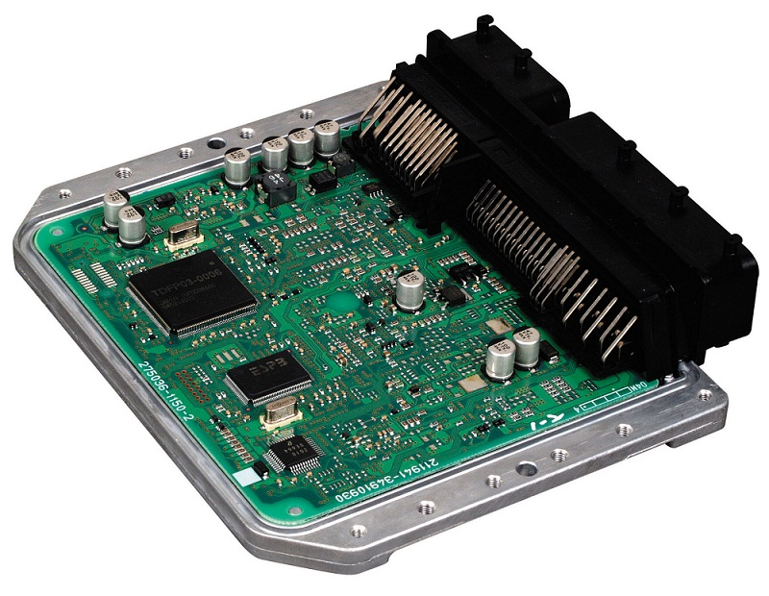(Fig.1) shows the electronic control unit for a Mercedes-Bins C43 car.

An ECU can adjust the operation of some components of the automobile as the case with the throttle pedal. On slower and twister tracks, the engine control system Will help the driver gain more control over the throttle input by making the throttle's first half very sensitive trough circuit set-up. On the other hand, at high speeds, the circuit preparation for the accelerator will be made as to apply full engine acceleration at small movement.

## 1.2 ECU types

* Types of ECUs (according to their use) are listed below:

1. ECM: Engine Control Module.
2. EBCM: Electronic Brake Control Module.
3. PCM: Powertrain Control Module.
4. VCM: Vehicle Control Module.
5. BCM: Body Control Module.

* A briefing of each type is listed in the following section:

1. **Engine Control Module (ECM):**

The ECM is an ECU in an internal combustion engine that control various engine

functions like fuel injection, ignition timing and idle speed control system. The control is done based on data (like engine coolant temperature, air flow, crank etc.) received from various sensors.

1. **Electronic Brake Control Module (EBCM):**

This ECU is used in the ABS (anti-lock braking system) module of a Car. It was introduced to improve vehicle braking irrespective of the road and whether conditions. The EBCM regulates the braking systems on the basis of five inputs that it receives:

* The Brake: This input gives the status of the brake pedal i.e. deflection or assertion. This information is acquired in a digital or analog format.
* The 4 WD: This input gives the status in digital format whether the vehicle is in the wheel-drive mode.
* The Ignition: This input registers if the ignition key is in place, and if the engine is running or not.
* Vehicle Speed: This input gives the information about the speed of the vehicle.
* Wheel speed: In a typical application this will represent a set Of 4 input signals that convey the information concerning the speed of each wheel. This information is used to derive all necessary information for the control algorithm.

1. **Powertrain Control Module (PCM):**

The PCM monitors and cmtrols speed control, A/C, charging and Automatic

Transmission. The inputs that are fed to the PCM are from:

* Throttle position sensor,
* Output shaft speed sensor.
* Vehicle speed sensor.
* Erwine (CO).
* Brake switch.
* Cruise control switches.
* Ignition.
* Overdrive on/off switch.
* Governor pressure sensor.

Using these inputs it does transmission control, valve control through PWM outputs, torque Converter clutch and transmission protection relay control and provides the feedback to the driver through the lamp.

1. **Vehicle Control Module (VCM):**

VCM is an ECU that takes care Of systems like:

* Electronic Power steering (EPS) systems
* Adaptive Cruise control (ACC) systems
* Airbag control system (ACS) systems.
* Electronic Stability Control (ESC) systems.

The VCM is connected to various kinds Of sensors to control various systems in the car. It takes inputs from crash sensors (micro-machined accelerometers) and sensors that detect occupant seatirw position, seat belt use and seat position to determine the force with which the frontal air bags should deploy. Similarly it takes inputs from Steering wheel angle sensors, Wheel speed sensors, Yaw rate sensors, Lateral acceleration sensors to provide an output to the ESC for the safest driving experience.

1. **Body Control Module (BCM):**

It is an ECU that takes care of seating control unit, wiper control, power windows and power hoods in convertible cars (e.g. Benz SL Roadster).

## 1.3. Common automobile sensors & the associated I/O signals

Engine sensors that are almost used in every automobile engine work on monitoring the crucial parameters required for generating the signal for the fuel injectors and spark plugs.

These sensors are mentioned as follows:

1. Oxygen sensor.
2. Throttle position sensor.
3. Crankshaft position sensor.
4. MAP sensor.
5. Engine coolant temperature sensor.
6. MAF Sensor.

In the following. a brief explanation for the concept of work for each sensor is listed:

1. **Oxygen sensor:**

This sensor is installed on the exhaust manifold and works on measuring the ratio of the air-fuel mixture. It determines whether the burning is lean or rich. The signal that the oxygen sensor returns is an analog signal. The oxygen sensor is shown in Fig.2.

Flg.2: Oxygen sensor

1. **Throttle position sensor (or conventionally known as TPS):**

This sensor is a potentiometer that is located at the butterfly spindle which measures the throttle position of the butterfly valve to determine how much air is flowing in. Typically, this sensor sends input data for:

* Traction control.
* Fuel injectors.
* Cruise control.

The TPS sends its signal in the form of varying voltage as it is a variable resistance. Fig.3 shows

the TPS.

Fig.3: Throttle position sensor

1. **Crankshaft position sensor:**

This sensor is an encoder that works on monitoring the crank shaft position in order to control ignition timing and other important engine parameters. It gives feedback in the form of frequency. The crankshaft position sensor is shown in Fig.4

Fig. 4: Crankshaft position Sensor

1. **MAP sensor:**

Manifold Absolute pressure sensor, is a pressure sensor that measures the pressure of air inside the intake manifold. This data is crucial for the ECU to determine how much fuel is needed to be injected by the fuel injectors. This sensor can do the application of Mass Air Flow sensor (MAFI by calculating the air density; this implies the need for data received from air temperature sensor. The MAP sensor sends its data in analog form. Figs shows the MAP sensor.

1. **Engine coolant temperature sensor (or conventionally known as ECT sensor):**

This sensor works on measuring the engine coolant temperature. This measured

temperature is sent to the ECU in order to adjust the fuel injection or the ignition timing. ECT sensor sends data in the form of varying voltage as it consists of a thermistor which is the main sensing component of the sensor. Engine coolant temperature sensor is shown in Fig.6.

1. **Mass Air Flow sensor (or conventionally known as MAF sensor):**

Mass Air Flow sensor is a sensor that measures the mass flow of air entering the intake manifold. In a typical system, either MAF or MAP is used for this purpose; rarely does it happen to include both in a single system. This sensor's signal is initially a varying current is converted to digital signal by means Of a circuit. Fig.? shows the MAF sensor.

## 1.4. Types of protocols

Automobile protocols can be divided into the following three major categories:

* Diagnostics
* Body and powertrain
* Multimedia and drive by wire

A brief explanation for each category is shown in the following section:

1. **Diagnostics:**

On-board diagnostics are into existence from the early 1980's. But in the recent years they have become highly sophisticated. Thus there are highly reliable protocols just used for on-board diagnostics.

Some of the most frequently used ones are:

* **OBDII protocol:** This is a one of the most popularly used standards introduced in the mid 90's and takes care of the complete engine control and monitoring of the chassis and the accessories. It is used by almost all the automakers.
* **CAN ISO 11898:** Another very popular protocol used by almost all the automaker for on- board diagnostics. The pin details are as below.
* Pin 2 - J1850 Bus+
* Pin 4 - Chassis Ground
* Pin 5 - Signal Ground
* Pin 6 -CAN High 0-2284)
* Pin 7 - ISO 9141-2 K Line
* Pin 10 -11850 Bus
* Pin 14 - CAN Low (1-2284)
* Pin 15 - ISO 9141-2 L Line
* Pin 16 - Battery Power
* **Keyword 2000 and J1850:** These protocols are basically used by GM, Chrysler for on- board diagnostics. J1850 is a very old protocol and is being phased out.

1. **Body and Powertrain:**

Body and Powertrain networks may consist of CAN, LIN, or J1850 protocols. CAN is versatile protocol and is majorly used in various categories of in-vehicle networks. High speed CAN is often used for Powertrain applications such as engine timing to ensure that the car runs efficiently.

**LIN:** Local Interconnect Network (LIN) is a IJART based network that was developed strictly for body applications. For example, a LIN network connects all of the electric devices in a car door. LIN and CAN may coexist. It is majorly used by Chrysler, BMW and Volkswagen.

1. **Multimedia and drive by wire:**

* **MOST**: It is a fiber optic network that has been optimized for use in the automobile. It is designed for use with simple devices such as microphones and speakers along with more complex devices such as security devices such as those used to locate stolen automobiles. MOST technology is being developed and promoted by a Cooperation, which includes BMW, Daimler-Chrysler, and Audi.
* **IDB 1394:** It is the latest addition to the IDB family of in-vehicle networks, designed for high speed multimedia applications that require large amounts of information to be moved quickly on a vehicle. previously known as IDB-M, IDB-1394 is built on IEEE-1394 technology that has already gained wide acceptance in the consumer electronics community. The IDB-1394 specification defines the automotive grade physical layers (e.g. cables, connectors), power modes, and the higher layer protocols needed to assure interoperability of all I DB-1394 devices.
* **FlexRay:** It is a scalable, flexible high-speed communication system, which meets the increasing technical demands in the automobile industry. With its data rate of up to 10 MBits/s, it is ideal for X- by wire applications.

## 1.5. Conventional ECU design procedures & testing

Earlier, the traditional way to develop automotive embedded systems was to build hardware boards that represent all or part of each ECU type and part of its surroundings, often called plant models, and use them for bench testing. Unfortunately, the bench approach has many limitations, which are:

* Creating all the needed hardware boards is costly.
* The performance requirements of the most powerful ECU types (i.e. PCM) are so
* demanding that it is no longer possible to build boards that allow adequate
* measurements to be taken.
* The bench testing approach is based on a sequential design process where hardware is developed, plant model prototypes are built then software development begins, so it is time consuming.

 In order to overcome these limitations, control design engineers have adopted a highly efficient design process often referred to as the "V" diagram. Though originally developed to encapsulate the design process of software applications, many different versions of this diagram can be found to describe different product design cycles. Fig.8 shows the design cycle followed by ECU manufacturers.

System Definition

System testing

Rapid Prototyping

Hardware in the-Loop testing

Targeting

"V-diagram", ECU design cycle

Following the V-diagram, the general progression of time in the development stages starts from left to right. However, this is often an iterative process, and the actual development will not proceed linearly through these steps. Instead, you will spend time in each step and even have to backtrack from time to time. The goal is to make this cycle as efficient as possible by minimizing the amount of backtracking between steps as well as the time spent in each step.

The y-axis of this diagram Can be thought of as the level at which the system components are considered. Early on in the development, the requirements of the overall system must be considered. As the system is divided into sub-systems and components, the process becomes very low-level down to the point of loading code onto individual processors.

Afterwards, components are integrated and tested together until such time that the entire system can enter final production testing. Therefore the top of the diagram represents the high-level system view and the bottom of the diagram represents a very low-level view.

A brief description for the steps of the V-diagram is shown in the following section:

1. **System Definition:**

In this step, the design engineers document the needs and requirements of the project using spreadsheet or word processing applications. The documentation also takes care of the various specifications of the engine and the various norms it needs to comply with. It also marks the limit levels of the parameters involved in controlling the engine.

Once the specifications are documented the actual design process begins in which first a software model of the ECU and the engine is built. Then, a software-in-the-loop simulation is performed. This is done by connecting both the models generated earlier together in a closed feedback loop and then simulating to analyze the dynamic characteristics of the entire system.

During the simulation, the ECU model monitors the output from the Engine model and adjusts the inputs to the Engine model in order to improve the Of various engine functions like fuel injection, ignition etc.

1. **Rapid Control Prototyping (or RCP):**

It is also called as Engine-in-the-loop Simulation (EIL). It should be clear that this is different from the term rapid prototyping (RP) which refers to a class of technologies that can automatically construct physical models from Computer-Aided Design (CAD) data. For RCP, the software ECU model that has been designed is downloaded to a Real-time Hardware prototype target. The Target can be any Real-time hardware (ideally a PXI system or a CRIO system). Thus, the software model of the ECU is given I/O interface which is in turn connected to sensors and actuators attached to the engine. Fig.9 shows a block diagram for the RCP process.

Flg.9: RCP process block diagram

The software that would be required is LabVlEW, LV RT and LV FPGA (if using CRIO or 78318 in PX'). If the model is built in MATRIXx then a dll can be created out of it and imported into LabVlEW where the I/O interface can be provided and the code can be downloaded into one of the Real-Time Hardware targets mentioned above. If it's a Simulink model then after being imported or translated into LabVlEW the I/O interface can be provided to the same Real- time Hardware target like PXI or CRIO.

1. **Targeting:**

In this step, the core ECU model is modified to interface with the I/O available in the actual ECU and then is converted into a C code using a C — code generator. And then this code is downloaded as the control algorithm to the 32-bit microcontroller inside the ECU.

1. **Hardware-in-the-loop simulation (HIL):**

Once the code containing the control algorithm is downloaded to the ECU, testing of the performance of the ECU under extreme conditions can be performed. These conditions cannot be achieved in the real world; the only way to achieve them is by the HIL simulation.

In performing the HIL simulation, the actual ECU is tested by simulating an engine using the Engine model that was already created in the system definition step. In vice-versa to the RCP step, in HIL the software model of the Engine is downloaded to a Real-time hardware and the appropriate I/O interfaces are provided. These I/O are then connected to the actual ECU. then various engine conditions can be simulated and the ECU can be tested to its limits which wouldn't be possible if it was tested using an actual Engine.

1. **System testing:**

System testing is performed continuously in order to set checkpoints and determine the need to perform backtracks and adjustments in the software. This is a critical task as the ECU software consists of millions of lines of code in order to comply with standards and restrictions set for controlling automotive emissions mainly.

This step is partially carried out in. every previous step, and can be simply put in the following:

* Fault finding, defect reporting and verification.
* Defect reporting and verification.
* Validation of automotive software at various levels of testing starting from unit level until system testing.
* Test suite automation using scripts and modeling tools like LabVlEW Validation on vehicle simulators / lab cars.
* Vehicle Diagnostics Services /Automotive Diagnostics Services / OBD Diagnostics services .
* Hardware-in-the-loop simulations & Engine-in-the-loop simulations.

## 1.6. Present work concept

Automotive manufacturing is highly restricted in terms Of their control units due to the

need for both following the standards and complying with the governing rules that limit and

retard the production speed of this industry. These restrictions thus render the automobile

ECUs standardized and highly limited in parameters' modification. This ensures safety ease

of operation for the normal use but forms a great ordeal for researchers looking for

investigating a certain phenomenon or attempting to improve the performance, reduce fuel

consumptimmetc.

In order to achieve a platform for researchers and amateurs to carry out their

investigations and introduce their suggested modifications with little restrictions that only

ensure the basic level of safety, a different way for the development of the ECU software was

to be followed. This software development way is basically based on interfacing the ECUs

microcontroller to the different sensors and actuators of the automobile, then calibrating the

contro"irw parameters by trial and error with the help of data obtairæd from an operational

reference ECU. The reference ECU was observed while operating a real engine. The observation

was in terms or its I/O signals to the different sensors and actuators connected to it for every

corresponding unique throttle valve opening.

This student-scale simplified ECU designation has also paved the way for the educational

field to deeply immerse in automotive control as well as other IC engines phenomena. It is an

open source for anyone willing to research, investigate or in the operation and control

of automobiles.

The ECU software at hand is a simple version that requires a lot of improvements for it

to be fully functional. At the meantime, it only controls the operation of the engine (Electronic

control with limitations for both acceleration and deceleration not to be of high

values. It also has a flexible architecture as it can be modified to comply with any type of

engines by changing certain control parameters in the C code and redesigning the PCB

interfacing circuit.

15

**2.1 Interior Combustion.**

**2.1.1 Introduction and operating cycles**

The reciprocating internal combustion engine must be by far the most common form of engine or prime mover. As with most engines, the usual aim is to achieve a high work output with a high efficiency; the means to these ends are developed throughout this book. The term “Internal Combustion Engine” should also include open circuit gas turbine plant where fuel is burnt in a combustion chamber. However, it is normal practice to ignore the prefix “reciprocating”; none the less this is the key principle that applies to both engines of different types and those utilizing different operating principles. The divisions between engine types and between operating principles can be explained more clearly. The modern motor vehicle engine burns a fuel to obtain power. The fuel is usually petrol (gasoline) or diesel. Motor vehicle engines are known as “Internal Combustion” engines since the energy from the combustion of the fuel, and the resulting pressure from expansion of the heated air and fuel charge, is applied directly to pistons inside closed cylinders in the engine. The term “reciprocating piston engine” describes the movement of the pistons, which go up and down in the cylinders. The pistons are connected by a rod to a crankshaft to give a rotary output. Fig 1. However, the two main types of internal combustion engines are: spark ignition (SI) engines, where the fuel is ignited by a spark; and compression ignition (Cl) engines, where the rise in temperature and pressure during compression is sufficient to cause spontaneous ignition of the fuel. The spark ignition engine is also referred to as the petrol, gasoline or gas engine from its typical fuels, and the Otto engine, the compression ignition engine is also referred to as the Diesel or oil engine. During each crankshaft revolution there are two strokes of the piston, and both types of engines can be designed to operate in either four strokes or two strokes of the piston.

Figure 1 Internal combustion engine internal components: crankshaft, connecting rods, pistons, valves, camshafts

**2.1.2 The four-stroke operating cycle**: it can be explained in figures (2-5). Fuel is metered into the engine together with an air charge for most petrol engines. However, some now use injectors that inject directly into the engine cylinder. In diesel engines, the fuel is injected into a compressed air charge in the combustion chamber. In order for the air and fuel to enter the engine and for the burnt or exhaust gases to leave the engine, a series of ports is connected to the combustion chambers, The combustion chambers are formed in the space above the pistons when they are at the top of the cylinders. Valves in the combustion chamber at the ends of the ports control the air charge and exhaust gas movements into and out from the combustion chambers. The valves are described as “poppet” valves and have a circular plate at right angles to a central stem that runs through a guide tube. The plate has a chamfered sealing face in contact with a matching sealing face in the port. The valve is opened by a rotating cam and associated linkage. It is closed and held closed by a coil spring. The opening and closing of the valves and the movement of the pistons in the cylinders follow a cycle of events called the “Four-stroke cycle” or the “Otto cycle” after its originator (Figs).

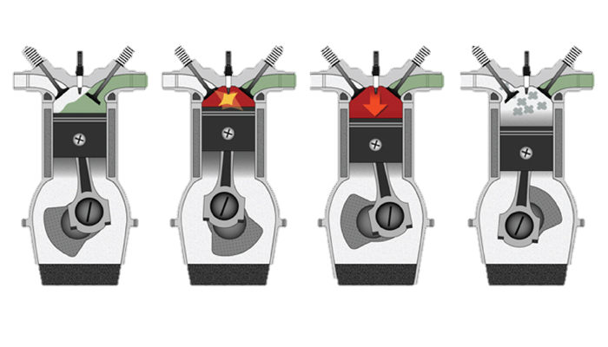

Intake Compression Combustion Exhaust

**Intake stroke.**

The first stroke of the four-stroke cycle is the induction or intake stroke. This occurs when the piston is moving down in the cylinder from top dead Centre (TDC) to bottom dead Centre (BDC) and the inlet valve is open, and the piston travels down the cylinder, drawing in a charge of air. In the case of a spark ignition engine the fuel is usually pre-mixed with the air. The movement of the pistons increases the volume of the cylinder so that air and fuel enter the engine.

* **Compression stroke.**

The next stroke is the compression stroke, when the piston moves upwards in the cylinder. Both the inlet and exhaust valves are closed and the space in the cylinder above the piston is reduced. This causes the air and fuel charge to be compressed, which is necessary for clean and efficient combustion of the fuel. Towards the end of the compression stroke.

* **Power stroke.**

The fuel is ignited and burns to give a large pressure rises in the cylinder above the piston. This pressure rises forces the piston down in the cylinder on the combustion or power stroke.

* **Exhaust stroke.**

Once the energy from the fuel has been used, the exhaust valve opens so that the waste gases can leave the engine through the exhaust port. To complete the exhausting of the burnt gases the piston moves upward in the cylinder. This final stroke is called the exhaust stroke. The four-stroke cycle then repeats over and over again, as the engine runs.

A heavy flywheel keeps the engine turning between power strokes. On the induction stroke of a petrol engine (most types), air and petrol enter the cylinder so the inlet valve in the inlet port must be open. While in diesel, and gasoline (petrol) direct injection engines, only air enters the cylinder. A rotating cam on the camshaft provides a lifting movement when it runs in contact with a follower. A mechanical linkage is used to transfer the movement to the valve stem and the valve is lifted off its seat so that the inlet port is opened to the combustion chamber. The air and fuel charge or air charge can now enter the cylinder. The inlet valve begins to open shortly before the piston reaches TDC. The exhaust valve, which is operated by its own cam in the same way as the inlet valve, is beginning to close as the piston passes TDC at the end of the exhaust stroke. Valve overlap helps clear the remaining exhaust gases from the combustion chamber. The incoming air charge fills the combustion chamber as the last quantity of exhaust gas leaves through the exhaust port. This is known as “scavenging”; it helps cool the combustion chamber by removing hot exhaust gases and gives a completely fresh air charge. All internal combustion engines have an induction, compression, expansion and exhaust process. For a four-stroke engine, each of these processes requires half an engine revolution, so the complete engine cycle takes two complete engine revolutions.



*Figure 6 Petrol engine indicator diagram: 1- Introduction; 2-Compression; 3-Power 4- Exhaust.*

The combustion process creates energy within the cylinder in the form of heat from the burning fuel/air mixture. Owing to the enclosed nature of the cylinder, this heat energy creates a pressure rise in the cylinder above the piston. This pressure, applied over the piston area, in turn, creates a force pushing down on the piston and turning the crankshaft via the connecting rod, thus producing torque at the crankshaft. The pressure in the cylinder is shown plotted against cylinder volume in Fig.6. This is known as an indicator diagram.

**2.1.3 Intake manifold.**

The intake manifold is a system designed to deliver air to the engine through pipes to each cylinder, called runners. The inside diameter of the runners must be large enough so that a high flow resistance and the resulting low volumetric efficiency do not occur. On the other hand, the diameter must be small enough to assure high air velocity and turbulence, which enhances its capability of carrying fuel droplets and increases evaporation and air-fuel mixing. The length of a runner and its diameter should be sized together to equalize, as much as possible, the amount of air and fuel that is delivered to each separate cylinder. The amount of air and fuel in one runner length is about the amount that gets delivered to one cylinder each cycle. On SI engines, air flow rate through the intake manifold is controlled by a throttle plate (butterfly valve) usually located at the upstream end. The throttle is incorporated into the carburetor for those engines so equipped. Fuel is added to inlet air somewhere in the intake system-before the manifold, in the manifold, or directly into each cylinder. It is found that when fuel is added early in the intake system, the flow of fuel through the manifold occurs in three different manners. Fuel vapor mixes with the air and flows with it. Very small liquid fuel droplets are carried by the air flow, smaller droplets following the streamlines better than larger droplets.

* **Definitions.**

**Spark Ignition (SI):** An SI engine starts the combustion process in each cycle by use of a spark plug. The spark plug gives a high-voltage electrical discharge between two electrodes which ignites the air-fuel mixture in the combustion chamber surrounding the plug. In early engine development, before the invention of the electric spark plug, many forms of torch holes were used to initiate combustion from an external flame.

**Compression Ignition (CI**): The combustion process in a CI engine starts when the air-fuel mixture self-ignites due to high temperature in the combustion chamber caused by high compression.

**Four-Stroke Cycle**: A four-stroke cycle experiences four piston movements over two engine revolutions for each cycle.

**Reciprocating**: Engine has one or more cylinders in which pistons reciprocate back and forth. The combustion chamber is located in the closed end of each cylinder. Power is delivered to a rotating output crankshaft by mechanical linkage with the pistons.

**Top-Dead-Center (TDC)**: Position of the piston when it stops at the furthest point away from the crankshaft. Top because this position is at the top of most engines (not always), and dead because the piston stops at this point. Because in some engines top-de ad-center is not at the top of the engine.

**Bottom-Dead-Center (BDC)**: Position of the piston when it stops at the point closest to the crankshaft.

**Direct Injection (DI)**: Fuel injection into the main combustion chamber of an engine.

**Stroke**: Movement distance of the piston from one extreme position to the other: TDC to BDC or BDC to TDC.

**Clearance Volume**: Minimum volume in the combustion chamber with piston at TDC.

**Smart Engine**: Engine with computer controls that regulate operating characteristics such as air-fuel ratio, ignition timing, valve timing, exhaust control, intake tuning, etc. Computer inputs come from electronic, mechanical, thermal, and chemical sensors located throughout the engine.

**Engine Management System (EMS)**: Computer and electronics used to control smart engines.

**Camshaft**: Rotating shaft used to push open valves at the proper time in the engine cycle.

**Combustion chambers**: The end of the cylinder between the head and the piston face where combustion occurs. The size of the combustion chamber continuously changes from a minimum volume when the piston is at TDC to a maximum when the piston is at BDC. The term "cylinder" is sometimes synonymous with "combustion chamber".

**Exhaust**: system Flow system for removing exhaust gases from the cylinders.

**Fuel injector**: A pressurized nozzle that sprays fuel into the incoming air on (SI) engines. The fuel injectors are located at the intake valve ports on multipoint port injector systems and upstream at the intake manifold inlet on throttle body injector systems. In a few SI engines, injectors spray directly into the combustion chamber.

**Fuel pump:** Electrically or mechanically driven pump to supply fuel from the fuel tank (reservoir) to the engine. Many modern automobiles have an electric fuel pump mounted submerged in the fuel tank.

**Piston**: The cylindrical-shaped mass that reciprocates back and forth in the cylinder, transmitting the pressure forces in the combustion chamber to the rotating crankshaft. The top of the piston is called the crown and the sides are called the skirt. The face on the crown makes up one wall of the combustion chamber and may be a flat or highly contoured surface. Some pistons contain an indented bowl in the crown, which makes up a large percent of the clearance volume. Pistons are made of cast iron, steel, or aluminum.

**Piston rings**: Metal rings that fit into circumferential grooves around the piston and form a sliding surface against the cylinder walls.

**Spark plug**: Electrical device used to initiate combustion in an SI engine by creating a high-voltage discharge across an electrode gap.

2.2.4 **ENGINE EMISSIONS AND AIR POLLUTION.**

Air pollution was recognized as a major problem in most cities around the world. However, four major emissions produced by internal combustion engines are hydrocarbons (HC), carbon monoxide (CO), oxides of nitrogen (NOx), and solid particulates (lead). Anyways, there are two methods, which are being used to reduce harmful engine emissions. One is to improve the technology of engines and fuels so that better combustion Occurs and fewer emissions are generated. The second method is after treatment of the exhaust gases. This is done by using thermal converters or catalytic converters. By using the first method which is by using the ECU to determine the best timing for fuel injecting so that the fuel is not wasted or harmful.

**2.2 ECU.**

As the requirements for lower and lower emissions continue, together with the need for better performance, other areas of engine control are constantly being investigated. This control is becoming even more important as the possibility of carbon dioxide emissions being included in future regulations increases. Some of the current and potential areas for further control of engine operation are included

In this section, some aspects in more detail and introduce further areas of engine control. Some of the main issues are:

• Ignition timing

• Dwell angle

• Fuel quantity

• Exhaust gas recirculation (EGR)

• Idle speed.

An engine management system can be represented by the standard three stage model, as shown in Figure 7.



*Figure 7 Representation of complete engine control as the standard*

This representation shows closed loop feedback, which is a common feature, particularly related to:

• Lambda control (Air-Fuel ratio).

• Knock.

• Idle speed.

While, the block diagram shown as Figure 8 can further represent an engine management system. This series of “inputs” and “outputs” is a good way of representing a complex system. This section continues with a look at some of the less common “inputs and outputs”.



*Figure 8 General block diagram of an ignition and fuel control system*

2.2.1. **Electronic control unit (ECU).**

The ECU is based on digital electronics. There is an advantage of controlling injection and ignition by a single ECU lies in the use of common sensors. Certain sensor signals are analogue in form and must be converted to a digital equivalent. For this purpose, an analogue to digital converter is used and will convert such quantities as battery voltage, temperature sensor voltages, etc. into pulses which represent them in digital form. Sensors which already give a pulsating signal like engine speed and crankshaft position units, have inputs into pulse-shaping circuits. These circuits process the signals into sharp clean pulse waveforms, suitable for passing into the micro-computer.

2.2.2 **Ignition control angle**.

Correct ignition timing over the entire engine operating range is very important as the major impact on fuel consumption as well as on emission rates. Combustion within the cylinder can be divided into two phases:

1. Inflammation delay:

Which is time proportional.

1. Combustion angle proportional:

The equivalent crankshaft angle for the second phase is almost constant¸ over the entire engine operating range. Induced by the piston movement, turbulences accelerator with engine speed, as well as the combustion process.

2.2.3 **Why computers?**

As computers can carry out explicit instructions with blinding speed and almost flawless consistency. And much more precise way to control engine functions, or engine calibration. The automotive industry had already looked to microprocessors—processors contained on integrated circuits. Volkswagen introduced the first large-scale production, computer-controlled electronic fuel injection (EFI) system. These small computers, with their comparatively low cost, compact size and weight, great speed, and application flexibility, proved to be ideal for the industry. Probably the most amazing feature of the digital computer is its speed. Ultimately, there are five reasons why computers are being used to control so many systems on the automobile, including both engine management systems and non-engine systems. When compared to mechanical methods of control, computers provide:

• More precise control.

• Faster response.

• Increased dependability.

• The potential to add additional features and functions.

• Enhanced diagnostic capabilities.

2.2.4 **How computers work??!**

* **Communication signals.**

A computer uses voltage values or voltage pulses as communication signals; thus, voltage is often referred to as a signal or a voltage signal. There are two types of voltage signals: analog and digital (Figure 9). An analog signal’s voltage is continuously variable within a given range, and time is needed for the voltage to change. An analog signal is generally used to convey information about a condition that changes gradually and continuously within an established range. On and off creates a digital signal; voltage is either there or it is not. Digital signals are often referred to as square wave signals.

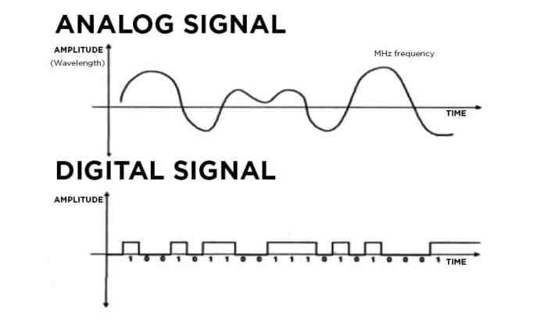

*Figure 9 Analog signals can be constantly variable. Digital signals are either on/off or low/high.*

* **Baud Rate**.

The frequency of the bits of binary code as they are communicated is known as the computer’s baud rate. Baud rate is expressed in bits per second (b/S), kilobits per second (Kb/S), or megabits per second (Mb/S).

* **Internal Circuits of the Computer.**

Microprocessor or Central Processing Unit (CPU). The microprocessor (an IC chip), also referred to as the central processing unit (CPU), is the heart of a computer and has the task of making all decisions to be made by the computer. The CPU records input information. It then compares this information with the internal programs. This results in a specific response on the output side of the computer. It then sends the proper commands to control the output circuits appropriately. In essence, the CPU per forms the data processing of the computer. Interface. The microprocessor makes all of the decisions, but it relies on several support functions, one of which is the interface. A computer has an input interface and an output interface, The interface has two functions: It protects the delicate electronics of the microprocessor from the higher voltages of the circuits attached to the computer, and it translates input and output signals. The input interface translates all sensor input data (including DC analog signals, AC analog signals, and variable digital frequency signals) to digital binary code. It is sometimes referred to as the analog-to digital or A/D, converter. The output interface, or D/A converter, translates digital binary signals to analog to control the actuators and other output signals. The transistors that control the outputs are located in the output interface and are called drivers. The microprocessor of a computer performs the calculations and makes all of the decisions, but it cannot store information. The computer is therefore equipped with information storage capability called memory There are two ways that computer memories are classified: An IC memory chip may be in the form of either read only memory (ROM) or random-access memory (RAM), and this memory chip may be classified as either volatile or nonvolatile.

2.2.5 **Engine control and diagnosis**.

The electronic engine control unit (ECU) has the task to control, optimize and supervise all relevant functions of an internal combustion engine (ICE). At first glance this comprises:

• torque generation according to the driver’s accelerator pedal.

• Low fuel consumption.

• Low exhaust emissions and low noise (compliance with legislation).

• Good driving behavior.

With regard to the general assembly of internal combustion engines the control functions can be dedicated to following engine subsystems or engine parts:

1. Intake system (air system).

2. Injection system.

3. Fuel supply.

4. Combustion and crankshaft drive.

5. Lubrication.

6. Exhaust gas system.

7. Cooling system.

2.2.6 **Combined control of ignition and fueling.**

The motor vehicle spark ignition engine has two supplying units for the production of power, one being the supply of atomized fuel in correct quantity and air: fuel ratio, the other being the supply of an igniting spark at the correct timing. For most of this century, covering the span of motor vehicle design, these two provisions of fueling and sparks have been dealt with separately. It will be noted that performance requirements, in line with emission regulations show that these are not separate subjects but are inter-dependent; the fact that a change in air: fuel ratio should have a corresponding change in ignition timing is an example. Digital electronic ignition circuits use a micro-processor (computer) for control of ignition sparks, and fuel injection also uses a micro-processor. There is spare capacity on one micro-processor, however, to analyze inputs and control outputs for both ignition and fueling, this being the basis for an engine management system. Using one central micro-processor for the control of other operations in addition to ignition and fueling leads to the concept of a total electronic management System (TECMS) in which, for example, the computing facility is applied to steering and suspension, gear change in automatic boxes, automatic fault diagnosis and control of clutch lock-up operation. Such a system would incorporate a fail-safe provision in the event of Computer failure. The single computer control of ignition and fueling is the main purpose of this paragraph, however, for such a system is now in wide use.

# Ch.3 Hardware

**3.1 Mechanical**

**3.2 Electrical**

**3.3 Electronics**

## 3.1 Mechanical

### 3.1.1 Internal Combustion Engine

An internal combustion engine (ICE) is a heat engine in which the combustion of a fuel occurs with an oxidizer (usually air) in a combustion chamber that is an integral part of the working fluid flow circuit. In an internal combustion engine, the expansion of the high-temperature and high-pressure gases produced by combustion applies direct force to some component of the engine. The force is applied typically to pistons, turbine blades, a rotor, or a nozzle.

#### 3.1.1.1Engine Parts

1. 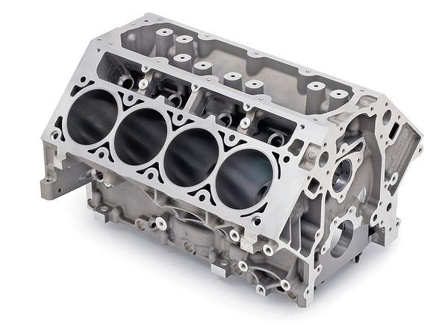**Engine Block**

An engine block is the structure which contains the cylinders, and other parts, of an internal combustion engine. In an early automotive engine, the engine block consisted of just the cylinder block, to which a separate crankcase was attached.

Modern engine blocks typically have the crankcase integrated with the cylinder block as a single component. Engine blocks often also include elements such as coolant passages and oil galleries.

Figure 1 : Engine Block

1. 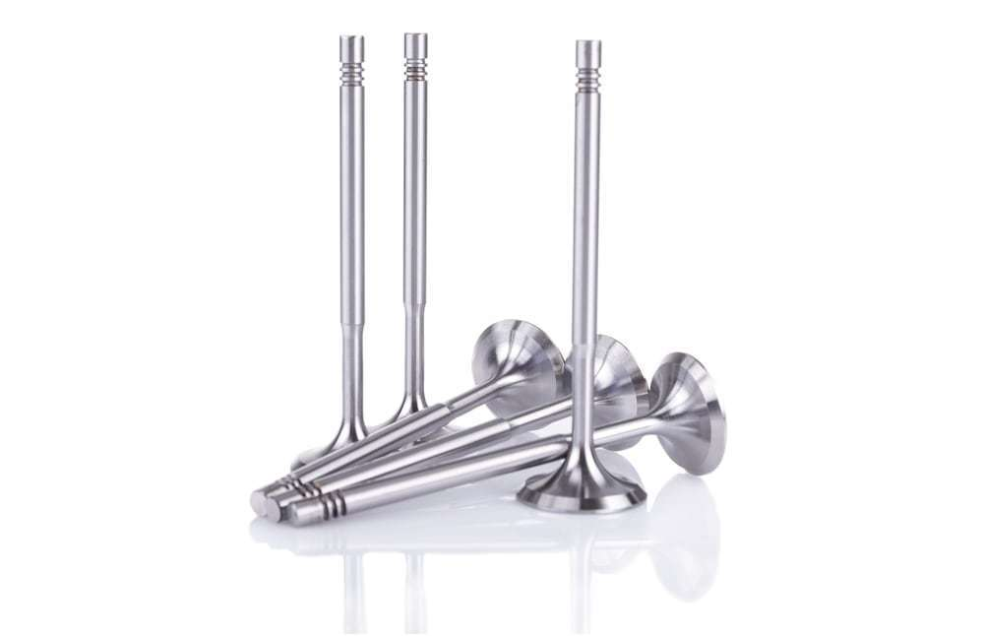 **Valves**

Engine valves are mechanical components used in internal combustion engines to allow or restrict the flow of fluid or gas to and from the combustion chambers or cylinders during engine operation.

1. 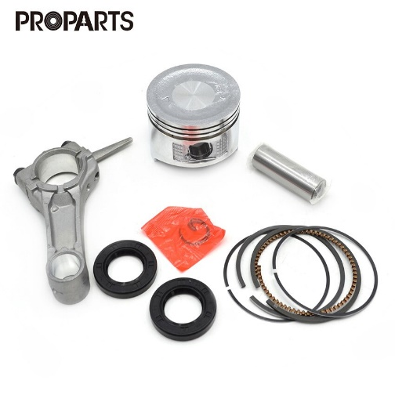 **Pistons and Connecting rod**

Figure 2 : Valves

It is the moving component that is contained by a cylinder and is made gas-tight by piston rings. In an engine, its purpose is to transfer force from expanding gas in the cylinder to the crankshaft via the connecting rod. The Piston ring is a metallic split ring that is attached to the outer diameter of a piston in an internal combustion engine.

The main functions of piston rings in engines are:

* Sealing the combustion chamber so that there is minimal loss of gases to the crank case.
* Improving heat transfer from the piston to the cylinder wall.
* Maintaining the proper quantity of the oil between the piston and the cylinder wall
* Regulating engine oil consumption by scraping oil from the cylinder walls back to the sump.

1. **Crankshaft**

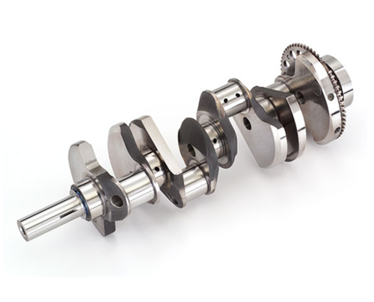A crankshaft is a rotating shaft which (in conjunction with the connecting rods) converts reciprocating motion of the pistons into rotational motion. Crankshafts are commonly used in internal combustion engines and consist of a series of cranks and crankpins to which the connecting rods are attached.

Figure 5: Crankshaft

1. **Camshaft**

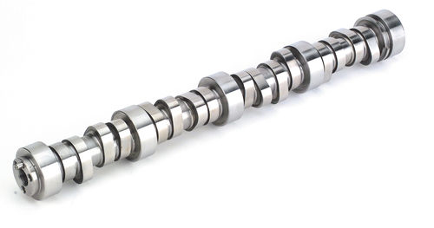A camshaft is a rotating object usually made of metal that contains pointed cams, which converts rotational motion to reciprocal motion. Camshafts are used in internal combustion engines (to operate the intake and exhaust valves)

Figure 6: Camshaft

1. **Cylinder Head and its Gasket**

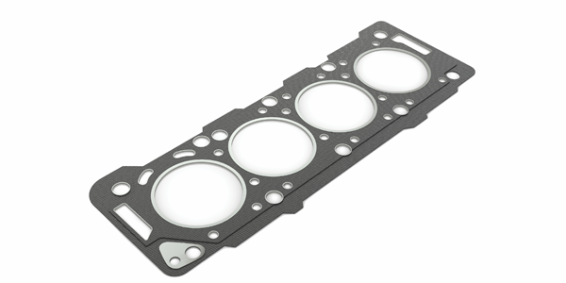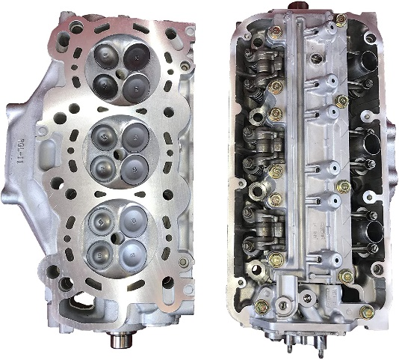In an internal combustion engine, the cylinder head contains the valves and sits above the cylinders on top of the cylinder block. It closes in the top of the cylinder, forming the combustion chamber. This joint is sealed by a head gasket that sits between the engine block and cylinder head(s) in an internal combustion engine. Its purpose is to seal the cylinders to ensure maximum compression and avoid leakage of coolant or engine oil into the cylinders.

1. **Timing Gears, Timing Belts and Chains**

* Timing gears: They are two, the first gear on the front of the crankshaft is in constant mesh with the second gear on the front of the camshaft.
* 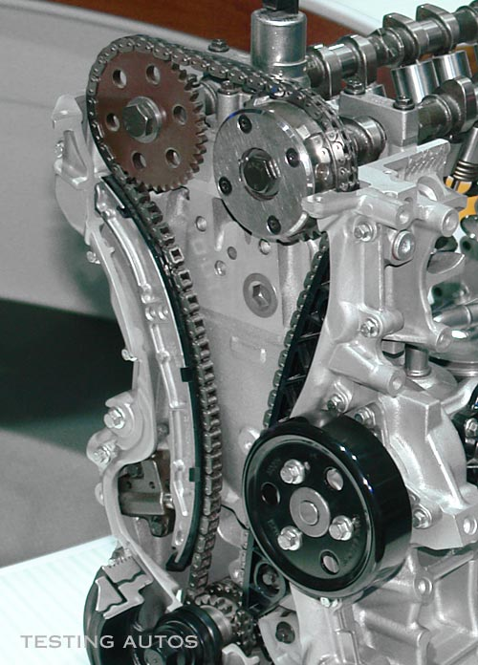Timing Chains: A timing chain is used when the spacing between the crankshaft and camshaft is too large to allow the gears to touch. A chain offers the advantages of being stronger, and not requiring regular replacement. One disadvantage is that a chain must run in oil, so it must be designed to sit inside the engine, which makes access more involved.

1. **Spark Plug & Fuel Injector**

* **Spark Plug** is a device for delivering electric current from an ignition system to the combustion chamber of a spark-ignition engine to ignite the compressed fuel/air mixture by an electric spark. While the **Fuel Injector** spray fuel into a car's engine using electronic controlled valves, capable of opening and closing many times a second.
* **There are two types of injection:**
* **Indirect Injection** in an internal combustion engine is fuel injection where fuel is not directly injected into the combustion chamber.
* **Direct injection** directly injects fuel into main combustion chamber which is gap between cylinder and piston where it penetrates into hot mass of compressed air.

#### 3.1.1.2 Used Engine

- Model : VolksWagen polo 2000

- configuration : inline 4 cylinder

- Displacement : 1.4 Liter (1400 CC)

- Fuel injection : Multi-point

- Valvetrain : DOHC (16 valve)

- Compression ratio : 10.5:1

## 3.2 Electrical

### 3.2.1 Ignition Coil

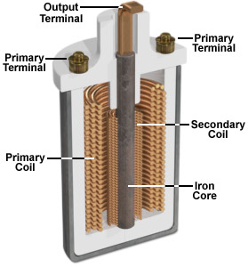Now most automobiles run on gasoline, which they burn in an internal combustion engine to convert into motion. For combustion to take place, a spark is needed to ignite the fuel mixture in the engine. The vehicle’s ignition system is designed so that a 12-volt battery can generate the very high voltage required to create such a discharge. The heart of this system is a device called an ignition coil.

Figure 1: Internal of ignition coil

This coil is a kind of transformer. Transformers transfer voltage from one circuit to another, either as a higher voltage (as in a step-up transformer, of which the ignition coil is an example), or a lower voltage (a step-down transformer). The key principle that makes transformers work is electromagnetic induction: a moving magnetic field, or a change in a stationary magnetic field (the case in our ignition coil), can induce a current in a wire exposed to that field.

This ignition coil is a pulse-type transformer. Like other transformers, it consists, in part, of two coils of wire. These are both wrapped around the same iron core. Because this is a step-up transformer, the secondary coil has far more turns of wire than the primary coil, which is wrapped around the secondary. In fact, the secondary coil has several thousand turns of thin wire, whereas the primary coil has just a few hundred. In your car, this allows some 40,000 volts of electricity to be generated by a modest battery.

* **The basic principle of an ignition coil**

To produce the required high voltages, ignition coils make use of the relationships that exist between electricity and magnetism.

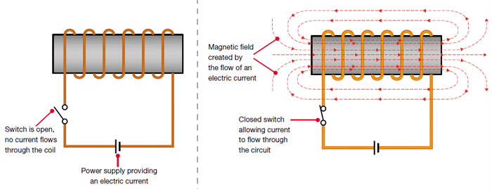When an electric current flow through an electrical conductor such as a coil of wire, it creates a magnetic field around the coil. The magnetic field (or, more precisely, magnetic flux) is effectively a store of energy, which can then be converted back into electricity.

Figure 2: Creating a magnetic field by flowing electric current through a coil

When the electric current is initially switched on, the current flow rapidly increases to its maximum value. Simultaneously, the magnetic field or flux will progressively grow to its maximum strength, and will become stable when the electric current is stable. When the electric current is then switched off, the magnetic field will collapse back in towards the coil of wire.

* **There are two main factors that affect the strength of the magnetic field:**

Increasing the current being applied to the coil of wire strengthens the magnetic field

The higher number of windings in the coil, the stronger the magnetic field.

* **Operation of Ignition coil**

For ignition coils (and many types of electrical transformer), the secondary winding is made with more windings than the primary winding. When the magnetic field collapses, it will therefore induce a higher voltage into the secondary winding than into the primary winding.

The secondary winding has more coils than the primary winding. When the magnetic field collapses, the voltage in the secondary coil will be greater than the voltage induced in the primary winding.

The primary winding of an ignition coil will typically contain 150 to 300 turns of wire; the secondary winding will typically contain 15,000 to 30,000 turns of wire, or around 100 times more than the primary winding.

The magnetic field is initially created when the vehicle’s electrical system applies approximately 12 volts to the ignition coil’s primary winding. When a spark is required at a spark plug, the ignition system will switch off the current flow to the primary winding, which will cause the magnetic field to collapse. The collapsing magnetic field will induce a voltage into the primary winding in the region of 200 volts, but the voltage induced into the secondary winding will be approximately 100 times greater, around 20,000 volts.

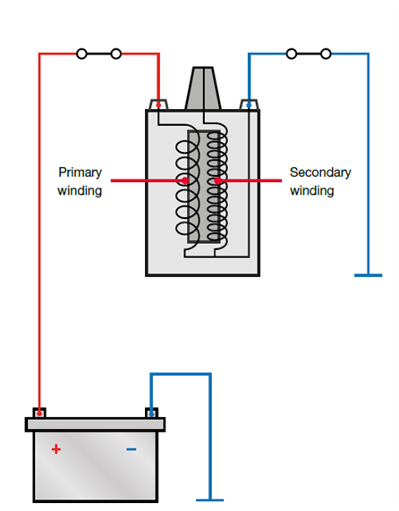By using the effects of mutual inductance and by using a secondary winding that has 100 times more windings than the primary winding, it is therefore possible to transform the original 12-volt supply into a very high voltage. This process of changing a low voltage into a high voltage is referred to as the ‘transformer action

In an ignition coil, the primary and secondary windings are wrapped around an iron core, which helps concentrate and enhance the strength of the magnetic field and flux, thus making the ignition coil more efficient.

Figure 3: Operation of Ignition coil

* **Used Ignition systems**

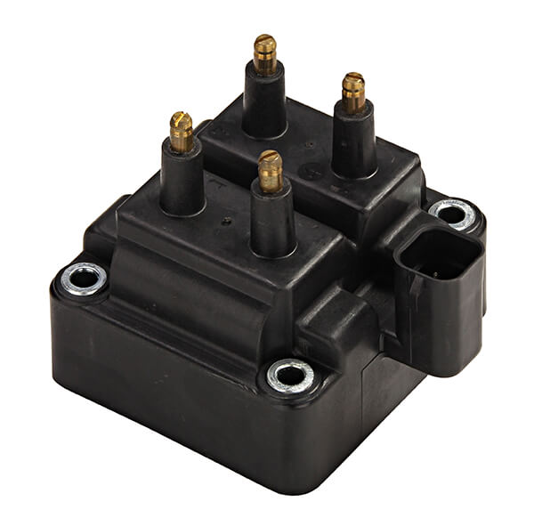**Wasted spark** ignition systems are a type of DIS, which uses one coil for every two cylinders. The coil provides the spark for one of the paired cylinders on the compression stroke and to the other on the exhaust stroke. Because the coil fires the spark plug on the exhaust stroke as well, it is appropriately named 'wasted spark ignition'. In effect, the spark plugs fire simultaneously and twice as often.

Figure 4: WASTED SPARK IGNITION COIL

Ignition Coil One of the two paired spark plugs is always negative polarity while the other spark plug is always positive polarity. Negative polarity means the spark plug's center electrode is negatively charged and its ground electrode is positively charged. Positive polarity is the opposite. Each time the plug fires, a rapid exchange of the protons and electrons occurs, called ionization.

The negatively charged electrons will be attracted to whichever side of the spark plug that is positively charged. The positively charged protons have much more mass than electrons, and thus cause more wear on the electrode they collide with. Hence, one plug will exhibit more wear on its ground electrode, while the other plug will experience more wear on its center electrode. If a spark plug with a precious metal on only the center electrode were to be used with this type of ignition system, there would be uneven wear on half the plugs. Although single precious metal or standard nickel plugs will still allow the engine to run, plug life will be greatly reduced.

Therefore, if a vehicle was originally equipped with dual precious metal spark plugs, replacement with a single precious metal or standard nickel plug may reduce plug life and engine performance.

In a four-cylinder engine, for example, cylinders 1 and 4 are connected to one ignition coil, and cylinders 2 and 3 to another. The ignition coils are triggered by the ignition output stages in the electronic control unit. This receives the TDC signal from the [crankshaft sensor](https://www.hella.com/techworld/uk/Crankshaft-sensor-4506/) in order to begin triggering the correct ignition coil.

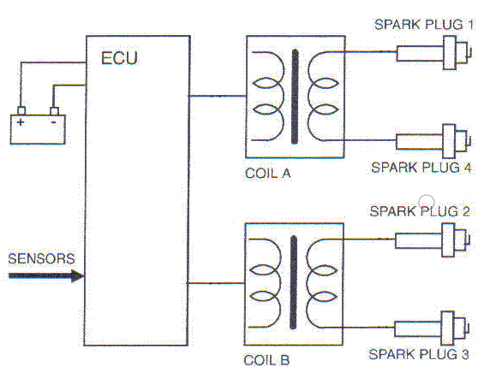

Figure 5: WASTED SPARK IGNITION SYSTEMS

* **The advantage of Wasted spark ignition systems**

That no distributor is needed, so there is no mechanical parts, wear or voltage drops. As a result, the coil needs less energy so can be made smaller. Usually in a 4-cylinder engine we’ll have two coils in one body – coil pack.

* **The disadvantage of Wasted spark ignition systems**

Is that there is firing in the exhaust strokes which implies that no fuel mixture may enter at that time because of valve overlap or any other reason. Otherwise, the fuel mixture will explode in the cylinder when is it at exhaust stroke and coarse damage to the engine. As result it is not always possible to get an optimum ignition timing. The other disadvantage is that those systems are more difficult to diagnose than the other ignition systems.

### 3.2.2 Spark Plug

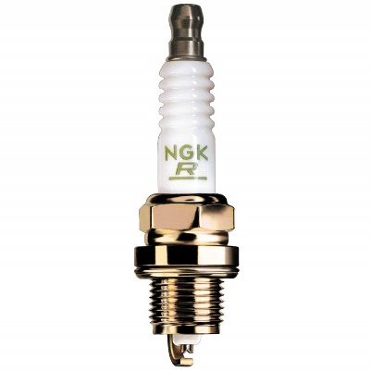A spark plug is an electrical device that fits into the cylinder head of some internal combustion engines and ignites compressed aerosol gasoline by means of an electric spark. Spark plugs have an insulated center electrode which is connected by a heavily insulated wire to an ignition coil or magneto circuit on the outside, forming, with a grounded terminal on the base of the plug, a spark gap inside the cylinder. Internal combustion engines can be divided into spark-ignition engines, which require spark plugs to begin combustion.

Figure 6: Spark Plug

* **The spark plug has two primary functions**

1. To ignite the air/fuel mixture. Electrical energy is transmitted through the spark plug, jumping the gap in the plugs firing end if the voltage supplied to the plug is high enough. This electrical spark ignites the gasoline/air mixture in the combustion chamber. To remove heat from the combustion chamber. Spark plugs cannot create heat, they can only remove heat. The temperature of the end of the plug\'s firing end must be kept low enough to prevent pre-ignition, but high enough to prevent fouling.
2. The spark plug works as a heat exchanger by pulling unwanted thermal energy from the combustion chamber and transferring heat to the engines cooling system. The heat range of a spark plug is defined as its ability dissipate heat from the tip.

* **Operation of Spark plug**

The plug is connected to the high voltage generated by an ignition coil or magnet. As the electrons flow from the coil, a voltage difference develops between the center electrode and side electrode. No current can flow because the fuel and air in the gap is an insulator, but as the voltage rises further, it begins to change the structure of the gases between the electrodes. Once the voltage exceeds the dielectric strength of the gases, the gases become ionized. The ionized gas becomes a conductor and allow electrons to flow across the gap. Spark plugs usually require voltage in excess of 20,000 volts to 'fire' properly.

As the current of electrons surges across the gap, it raises the temperature of the spark channel to 60,000 K. The intense heat in the spark channel causes the ionized gas to expand very quickly, like a small explosion. This is the "click" heard when observing a spark, similar to lightning and thunder.

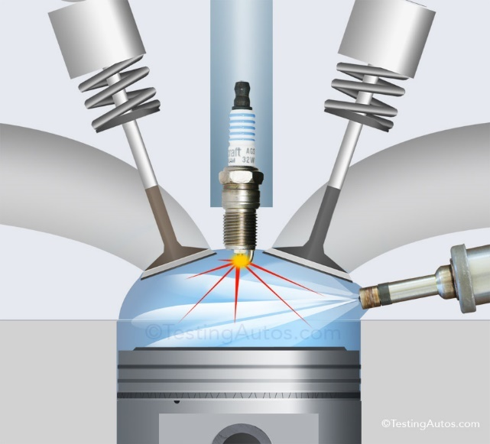The heat and pressure force the gases to react with each other, and at the end of the spark event there should be a small ball of fire in the spark gap as the gases burn on their own. The size of this fireball or kernel depends on the exact composition of the mixture between the electrodes and the level of combustion chamber turbulence at the time of the spark. A small kernel will make the engine run as though the ignition timing was retarded, and a large one as though the timing was advanced.

### 3.2.3 Fuel pump

A fuel pump is an essential component of the [fuel system](https://www.newkidscar.com/fuel-system/) on a car. Fuel pumps use in carbureted and injected engines. By the depending to where fuel pump are using, they divided on the different types of fuel pumps.

* **Purpose of Fuel Pump:**

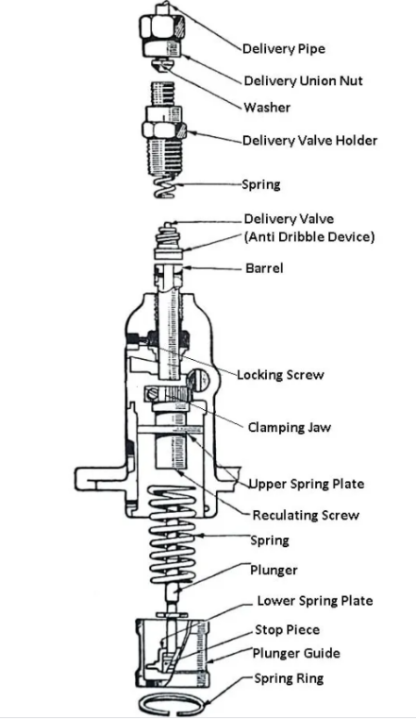The Fuel pump`s purpose is supply fuel from [fuel tank](https://www.newkidscar.com/fuel-system/fuel-tank-construction/) to the engine [cylinder](https://www.newkidscar.com/engine-construction/engine-cylinder-construction/). Fuel pump of modern injection systems must create the high pressure, so are often used Electrical fuel pumps.

There are three main types of fuel pumps that your vehicle may be equipped with. Each functions differently so it is important to understand the characteristics of one against another. For example, when shopping for a fuel pump, you will need to know if it pumps the gas into a carburetor or into the fuel injection system. Here’s more information on the different types and what they mean for you.

Construction and Working of a Fuel Pump: The plunger is driven by a cam and tappet mechanism at the bottom. The plunger reciprocates in the barrel. There are as many plungers as the number of cylinders in the engine. The plunger has a rectangular vertical groove. The delivery valve is lifted off its seat under the pressure of the fuel against the spring. The fuel from the delivery valve goes to the injector. When the plunger is at the bottom of its stroke, the supply port and spill are uncovered, the fuel from a low-pressure pump after filtration is forced into the barrel.

Now the plunger is pushed up by the cam movement and both the parts are closed. On further movements of the plunger, the fuel above it is compressed which lifts the delivery valve and the fuel through it goes to the injector.

The plunger rises up still further, and at a particular moment, the helical groove connects the spill port, through the rectangular groove to the fuel in the upper part of the plunger. Consequently, there is a sudden pressure drop due to which the delivery valve falls back on its seat under the spring force. The pressure in the delivery pipe also drops. Thus the discharged from the nozzle of the injector is cut off suddenly. The cycle is repeated again and again.

During each stroke of the plunger, the duration of the delivery is more or less according to as the spill port is made to communicate earlier or later, the high-pressure fuel in the upper part of the barrel. This depends upon the position of the helical groove which can be changed by rotating the plunger by the rack.

The rack is connected to the accelerator. It meshes with a geared quadrant. The motion of the rack rotates the gear quadrant which ultimately rotates the plunger. The driver simply operates the accelerator which controls the fuel supply to the engine cylinder.

**Types of Fuel Pumps:**The fuel pump is used in the fuel system to deliver fuel from the fuel tank to [the carburettor.](https://www.theengineerspost.com/types-of-carburetors/) Many types of fuel pumps are used in modern automobile vehicles.

**Low-pressure fuel pumps** – is mounted on the carbureted engines outside the fuel tank;

**High-pressure fuel pumps** – is mounted on diesel and injection engines.

The modern fuel injected engines often use **electric fuel pumps**, which are mounted inside the [**fuel tank**](https://www.newkidscar.com/fuel-system/fuel-tank-construction/).

A fuel pump draws petrol out of the fuel tank by a pipeline to the carburetor, so sometimes it names petrol pump. The mechanical pump has drive from an engine. And electric fuel pump is usually mounted near the tank or inside the tank.

The performance of fuel is tested by pressure, volume and vacuum. A pump must produce certain pressure on the outlet side as specified by the manufacturer. To test a pump for pressure, connect a pressure gauge between the pump and the carburettor and run the engine at a specified speed. The gauge will indicate the pressure created by the fuel pump.

For volume test, disconnect the fuel from the carburettor and run the engine at idling speed. Measure the volume of fuel coming out from the pump by collecting it in a separate container.

For vacuum test, connect a suitable vacuum gauge between the gauge tank and then run the engine at idling speed. The gauge indicates the vacuum generated inside the pump to suck the fuel from the fuel tank.

The vacuum must be retained for at least ten seconds after closing the engine. The fuel pump found connect in the above three tests should be used in the fuel system.

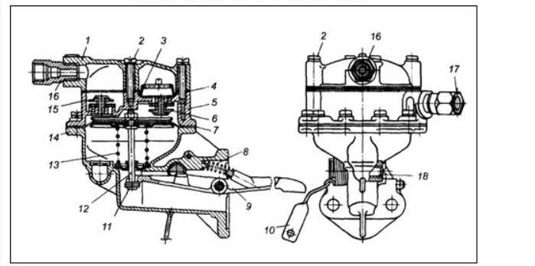

**Fuel pump diagram**

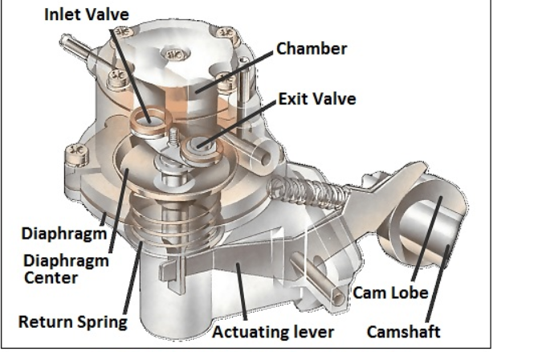

**Mechanical fuel pump**

* **How Mechanical pump works:**

Mechanical pump`s actuating lever moves up and down during the working. When need to fill the pump chamber lever pulls the diaphragm down.  The return spring moves the diaphragm up to deliver fuel to the carburetor device.

A mechanical fuel pump is driven by the camshaft , or by a special shaft driven by the crankshaft . As the shaft turns, a cam passes under a pivoted lever and forces it up at one end.

The other end of the lever, which is linked loosely to a rubber diaphragm forming the floor of a chamber in the pump, goes down and pulls the diaphragm with it.

When the lever pulls the diaphragm down, it creates suction that draws fuel along the fuel pipe into the pump through a one-way valve .

As the revolving cam turns further, so that it no longer presses on the lever, the lever is moved back by a return spring , relaxing its pull on the diaphragm.

The loosely linked lever does not push the diaphragm up, but there is a return spring that pushes against it.

The diaphragm can move up only by expelling petrol from the chamber. The petrol cannot go back through the first one-way valve, so it goes out through another one leading to the carburettor.

The carburettor admits petrol only as it needs it, through the needle valve in its float chamber (See [How variable-jet carburettors work](https://www.howacarworks.com/basics/how-variable-jet-carburettors-work) ). The first valve is one way, so the petrol cannot move back and moves to the carburetor through another valve.  The carburetor needle valve which mounted into the float chamber regulates admits the petrol as it needs.

In our time by the widespread adoption of electronic fuel injection are used electric fuel pumps. We will talk about electric fuel pumps in next paragraph.

In a mechanical pump the actuating lever moves up and down constantly, but pulls the diaphragm down only as needed to refill the pump chamber. The return spring pushes the diaphragm up to deliver petrol to the carburettor. While the carburettor is full and the needle valve is closed, no petrol leaves the pump. The diaphragm stays down, and the lever idles up and down.

When the carburettor accepts more petrol, the return spring pushes the diaphragm up and, by taking up the slack in the loose linkage, brings it back into contact with the lever, which again pulls it down to refill the pump chamber.

* 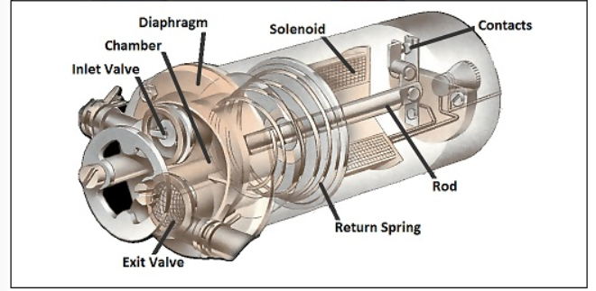**Electric Fuel Pump:**
* **How Electric Fuel Pump Works:**

An electric pump has a similar diaphragm-and-valve arrangement, but instead of the camshaft, a solenoid (an electromagnetic switch ) provides the pull on the diaphragm.

The solenoid attracts an iron rod that pulls the diaphragm down, drawing petrol into the chamber.

At the end of its travel the iron rod forces apart a set of contacts, breaking the current to the electromagnet and relaxing the pull on the diaphragm.

When the diaphragm return spring raises the diaphragm, it also pulls the rod away from the contacts; they then close so that the solenoid pulls the rod and diaphragm down again.

Circulating petrol continuously:

Most mechanical and electrical systems pump fuel only when the carburettor needs it. An alternative system has a complete circuit of pipes, from the tank to the carburettor and back again. The pump sends petrol continuously round this circuit, from which the carburettor draws petrol as it needs it

### 3.2.4 Injectors

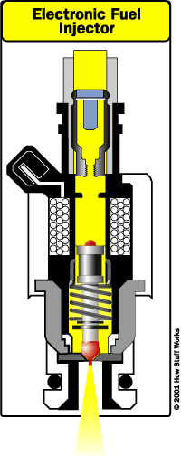Fuel injectors, fuel injection pumps (one per cylinder) and fuel filtration equipment are usually of the manufacturer's standard type, thoroughly proven in service elsewhere under similar operating conditions. Adequate redundancy is provided in the operating drive and metering control to ensure the engine is not made unserviceable by individual component failure.

Fuel injectors, incorporating filters, atomise the fuel sufficient for [complete combustion](https://www.sciencedirect.com/topics/engineering/complete-combustion). The injectors are easily removable for maintenance purposes, for which a maintenance jig (including a test pump), are provided.

The fuel injector pumps are individually cam-operated, of the spring-return plunger type and are driven off a common [camshaft](https://www.sciencedirect.com/topics/engineering/camshafts). They have means of ensuring equal distribution and metering of the fuel to all cylinders under all conditions of loading. Each pump is capable of being manually primed.

The fuel system is self-venting and any fuel spill from the injectors is returned directly to the fuel oil bulk storage tank.

Fuel pipes from the pumps to the injectors are sheathed such that any leakage is piped to a tank fitted with a level alarm.

Dual full-flow fine filters are provided upstream of the fuel injector pumps.

The amount of fuel supplied to the engine is determined by the amount of time the fuel injector stays open. This is called the pulse width , and it is controlled by the ECU.

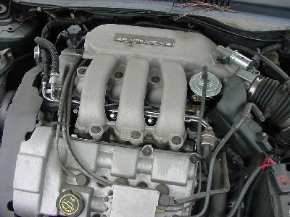

**Fuel injectors mounted in the intake manifold of the engine**

The injectors are mounted in the intake manifold so that they spray fuel directly at the intake valves. A pipe called the fuel rail supplies pressurized fuel to all of the injectors.

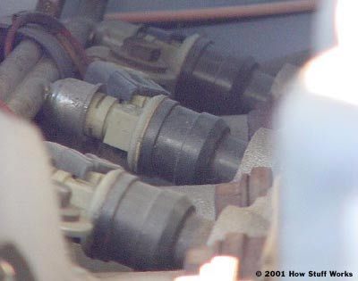In order to provide the right amount of fuel, the engine control unit is equipped with a whole lot of sensors.

**three of the injectors. The fuel rail is the pipe on the left.**

* **Types of Fuel injections:**

**1) Direct injection:**

direct injection is a method in which fuel is introduced into internal combustion engines. it’s common in gasoline (petrol) engines but is now employ on diesel engines to give the same quality to the engine types.

Direct injection systems are used in a gasoline engine to increase the efficiency and specific power output and also to reduce exhaust emissions.

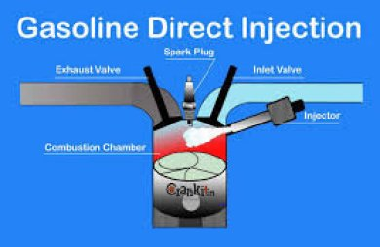

What is a direct injection system?

A direct injection system is a fuel injection process that allows fuel to be injected directly to the top of the piston in the combustion chamber. A gasoline direct injection (GDI) which is also known as petrol direct injection (PDI) is a mixture formation system for internal combustion engines that work with gasoline (petrol). Fuel is injected into the combustion chamber directly.

This direct gasoline engine was introduced in 1925 for a low-compression truck engine. it was quite popular on German cars, using a Bosch mechanical GDI system in the 1950s. it became more popular when introduced in an electronic GDI system in 1996 by Mitsubishi. However, the system has been widely adopted by the automotive industry in recent years.

The direct injection principle is firstly performed on diesel engines. it’s a basic type of fuel injection system diesel engine uses. Fuel is injected into the combustion chamber above the piston directly in a simple DI diesel engine. The compression of air inside the chamber rises in temperature above 400 degrees Celsius, which then ignites the diesel-fuel immediately it’s sprayed directly into the combustion chamber.

Functions of a direct injection system:

- To burn fuel efficiently

- To produce more power

- Cleaner emissions, and

- Increased fuel economy.

Components of a direct injection system

Below are the components of a direct injection fuel system:

- Fuel injection pump.

- High-pressure lines.

- Fuel feed pump.

- Fuel filter.

- Governor.

Diagram of a direct injection:

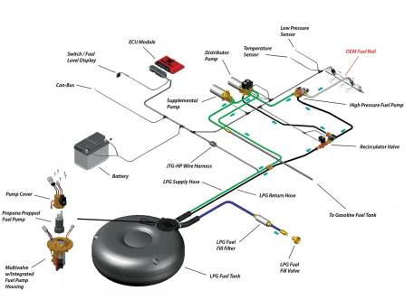

Working principle:

The working of a direct injection system is less complex and can be easily understood. Conventionally, gasoline engines work by sucking a mixture of gasoline and air into the cylinder. This mixture is compressed with a piston and then ignite with a spark from a spark plug to cause an explosion. This resulting explosion moves the piston downwards, producing power.

Traditionally, in an indirect fuel injection system, gasoline and air is pre-mix in a chamber outside the cylinder known as the intake manifold. Now in a direct injection system, air and gasoline are not pre-mixed. Instead, the air enters through the intake manifold, while the gasoline is injected directly into the cylinder.

In the combustion chamber, there is a way fuel is distributed into it, which is known as “charge mode”. This charge includes homogeneous charge mode and stratified charge mode. In the homogeneous charge mode, the fuel is mixed evenly with the air throughout the combustion chamber due to the manifold injection. Whereas in the stratified charge mode, there is a zone with a higher density of fuel around the spark plug, and a leaner mixture (lower density of fuel) is far away from the spark plug.

In a direct injection system, there are common techniques for creating a desired fuel distribution throughout the combustion chamber. These injection methods include spray-guided, air-guided, or wall-guided injection.

**Advantages and disadvantages of a direct-injection system**

**Advantages:**

Below are the benefits of direct injection in gasoline engines:

- Low maintenance.

- High low-end torque.

- Sturdiness.

- Longer engine life.

**Disadvantages:**

Despite the advantages of direct-inject some limitations still occur. below are the disadvantages of direct injection in gasoline engine:

Lower engine speeds and BHP.

- Working is Sluggish.

- Higher noise, vibrations, and harshness levels.

- Heavier engine components.

- No valve cleaning action.

- Producing peak power at high engine speed is limited.

**2) InDirect injection:**

An indirect injection in an internal combustion engine is when fuel is not directly injected into the combustion chamber. It’s common among auto enthusiasts that an indirect injection is equipped on only diesel engines, that’s the truth but it’s now employed on gasoline engines.

In gasoline engines with an indirect injection system, there is a fuel injector that delivers fuel at some point before the intake valve. Whereas, in diesel engines, fuel is delivered into a chamber of the combustion chamber, known as the prechamber. This will be further explained.

What is an indirect injection system?

Just as earlier mentioned, indirect fuel injection is a fuel injection process in internal combustion engines, in which fuel is not direct injected into the chamber. The invention helps to achieve higher engine speeds in diesel engines. it’s generally used in light-duty diesel engines, found in the earlier generation passenger cars, sedans, and multi-utility vehicles.

In an indirect injection system, injectors do not spray fuel directly over the piston, but instead, sprays the fuel into a pre-combustion chamber located inside the cylinder head. Some auto manufacturers now install a dual-injection system that combines direct and indirect injectors to obtain the benefits of both injection systems.

A direct injection system allows the fuel to be precisely metered into the combustion chamber under high pressure. this helps to obtain greater power and fuel efficiency. Limitations with this system are that it generally leads to particulate matter and also the fuel no longer contacts the intake valves. This will accumulate the amount of carbon over time.

Because of this, an indirect injection system will play a perfect role as it keeps spraying fuel on the intake valves. It will assist to remove the accumulated carbon on the intake valves and in low loads conditions.

Functions of indirect injection:

functions of indirect injection in diesel engines:

Indirect injection serves the purpose of increasing the engine speed as the power output is increased.

The addition of the pre-chamber increases heat loss to the cooling system.

Indirect injection allows air to move faster to mix with the fuel in the system.

Characteristic of an indirect injection system

Below are the characteristics of an indirect combustion chamber:

Swirl chamber – a swirl chamber allows about 50% of fuel to enter into it during a compression stroke. It’s a spherical chamber located in the cylinder head.

Pre-combustion chamber – during the compression stroke, air from the main cylinder moves to the pre-combustion chamber to begin the combustion. This chamber is located at the cylinder head and is connected to the engine cylinder by some tiny holes.

Air cell chamber – this is a cylindrical chamber with a hole in one end. It’s mounted more or less coaxially to the fuel injection; it’s done so that thermal contact can be minimized with the mass of the head.

Components of an indirect injection system

Components of an indirect injection in an automotive diesel engine include top of the head, piston, injection holes, cylinder head, injection pump, head close up, combustion chambers, and glow plugs. All this will be mention and explain in the working principle section.

Diagram of an indirect injection system:

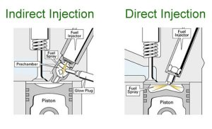

Working principle

The working of an indirect injection is quite simple and easy to understand. In the system, fuel is sprayed into a separate chamber, known as a pre-combustion chamber. Unlike the conventional internal combustion diesel engines that atomize fuel directly over the piston.

This pre-combustion chamber is located inside the cylinder head, creating a swirling action in the compressed air. With this, the mixing of fuel with air is achieved uniformly. in this system, the air is allowed to move fast while mixing the fuel and air.

During the compression stroke, the air from the engine cylinder will first enter the pre-combustion chamber. As it compresses, its temperature rises, making the air becomes extremely hot. At this point, an injector injects fuel into the pre-combustion chamber.

For this reason, combustion begins and then the entire cylinder will be spread.

Advantages and disadvantages of an indirect injection system

Advantages:

Below are the benefits of an indirect injection system in diesel engines:

- Possibility of producing smaller size diesel engines suitable for cars.

- Higher engine speeds can be achieved than direct injection diesel engines

- Because of low injection pressure, the injectors are cheaper to produce.

- Lower stresses are created on its internal components. this is making It possible to make the basic common platform for petrol and diesel versions of the same engine to save cost.

- Injection direction is less important.

- Much simpler to design and manufacture.

- Higher engine speed is reached due to the continuous burning in the prechamber.

Disadvantages:

Despite the advantages of indirect injection, some limitations still occur. below are the disadvantages of an indirect injection system in diesel engines:

- Indirect injection systems require glow plugs for a cold engine start on diesel engines.

- Fuel efficiency is lower than with direct injection because of the large exposed areas in the system causing heat loss. And also, pressure loss due to air motion through the throats.

- Since heat and pressure of combustion are applied to one point on the piston as it exists in the precombustion chamber. This makes such engines to be less suited to high power outputs than direct injection diesel engines.

**Cars Electrical System**

The electrical system of a car has two main functions. First, it must supply electrical energy to start and operate the engine. Secondly, it must provide the power to operate the lights, instruments and other electrical accessories.

The modern car has about 60 meters of wire joining its electrical components. A color code has been standardized in most cars to allow quick recognition of the different circuits when any repairs are necessary.

The electrical system is usually divided into five circuits. They are the ignition circuit, starter circuit, charging circuit, lighting circuit and the accessories circuits, which are sometimes controlled by the ignition switch and in most cases protected by a fuse.

The electrical components in a car are connected through switches to one side of the battery, the other side of the battery is connected to the car body or chassis. In this way, the circuit to any component is completed through the car body which becomes the earth return. This method of wiring saves the cost of about 30 m of wire and also reduces the possibility of disconnection and simplifies fault-finding.

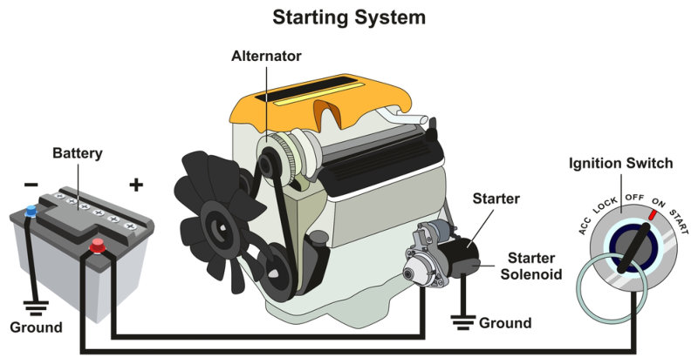

Figure 1 Car Electrical System

**Main Components of The Electrical System**

Current for a car’s electrical system is supplied by the battery when the engine is not running and by the generator, which is often a dynamo on older models. In most modern cars now an alternator is fitted as it more easily supplies the current needed for the various accessories.

All the current is at the voltage of the battery usually 12 V or the generator (approx. 15 1/2 volts) except the current to the spark plugs which is boosted by the ignition system to as much as 30,000 volts.

The generating or charging system has three basic components the battery, the alternator and the regulator.

**Battery**

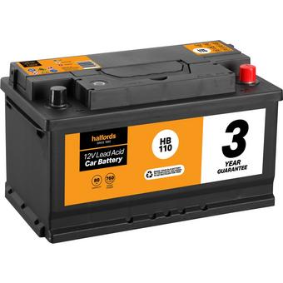The battery is a rechargeable battery that is used to start a motor vehicle. Its main purpose is to provide an electric current to the electric-powered starting motor, which in turn starts the chemically-powered internal combustion engine that actually propels the vehicle. Once the engine is running, power for the car's electrical systems is still supplied by the battery, with the alternator charging the battery as demands increase or decrease.

Figure 2 Battery

Typically, starting uses less than three percent of the battery capacity. For this reason, automotive batteries are designed to deliver maximum current for a short period of time. They are sometimes referred to as "SLI batteries" for this reason, for starting, lighting and ignition. SLI batteries are not designed for deep discharging, and a full discharge can reduce the battery's lifespan. As well as starting the engine, the SLI battery supplies the extra power necessary when the vehicle's electrical requirements exceed the supply from the charging system. It is also a stabilizer, evening out potentially damaging voltage spikes. While the engine is running, most of the power is provided by the alternator, which includes a voltage regulator to keep the output between 13.5 and 14.5 V.

**The Alternator**

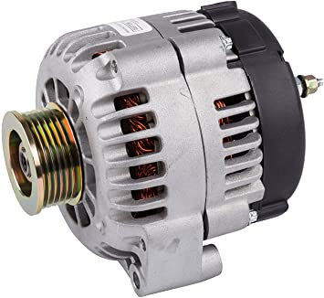Alternators are typically found near the front of the engine and are driven by the crankshaft, which converts the pistons up-and-down movement into circular movement which is used to charge the battery and power all the electrical systems and accessories. Some early model vehicles used a separate drive belt from the crankshaft pulley to the alternator pulley, but most cars today have a serpentine belt, or one belt that drives all components that rely on crankshaft power.

Figure 3 The Alternator

Most alternators are mounted using brackets that bolt to a specific point on the engine. One of the brackets is usually a fixed point, while the other is adjustable to tighten the drive belt. A regulator used with the alternator protects the battery and other electrical equipment from receiving too much electrical power.

**The Starter**

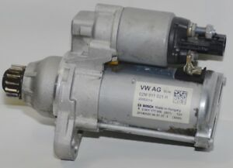The starter motor converts electrical energy from the battery into mechanical energy. When you turn the key in your car’s ignition, the engine turns over and then cranks. However, getting it to crank is actually much more involved than you might think.

Figure 4 The Starter

It requires a flow of air into the engine, which can only be achieved by creating suction. If your engine isn’t turning over, there’s no air. No air means that fuel can’t combust.

The starter motor is responsible for turning the engine over during ignition and allowing everything else to happen. When you turn the ignition on, the starter motor engages and turns the engine over allowing it to suck in air.

On the engine, a flywheel, with a ring gear attached around the edge, is fitted to the end of the crankshaft.

On the starter, the pinion is designed to fit into the grooves of the ring gear. When you turn the ignition switch, the electromagnet inside the body engages & pushes out a rod to which the pinion is attached. The pinion meets the flywheel and the starter motor turns. This spins the engine over, sucking in air (as well as fuel).

As the engine turns over, the starter motor disengages, and the electromagnet stops. The rod retracts into the starter motor once more, taking the pinion out of contact with the flywheel and preventing potential damage.

## 3.3 Electronics

### 3.3.1 AVR AtMega128

* **Overview**

The Atmel® AVR® ATmega128 is a low-power CMOS 8-bit microcontroller based on the AVR enhanced RISC architecture. The Atmel® AVR® core combines a rich instruction set with 32 general purpose working registers. All the 32 registers are directly connected to the Arithmetic Logic Unit (ALU), allowing two independent registers to be accessed in one single instruction executed in one clock cycle. The resulting architecture is more code efficient while achieving throughputs up to ten times faster than conventional CISC microcontrollers.

* **Pin Configurations**

**VCC:** Digital supply voltage.

**GND:** Ground.

**Port A (PA7..PA0) :**Port A is an 8-bit bi-directional I/O port with internal pull-up resistors (selected for each bit).

**Port B (PB7..PB0) :**Port B is an 8-bit bi-directional I/O port with internal pull-up resistors (selected for each bit).

**Port C (PC7..PC0) :**Port C is an 8-bit bi-directional I/O port with internal pull-up resistors (selected for each bit).

**Port D (PD7..PD0) :**Port D is an 8-bit bi-directional I/O port with internal pull-up resistors (selected for each bit)..

**Port E (PE7..PE0) :**Port E is an 8-bit bi-directional I/O port with internal pull-up resistors (selected for each bit).

**Port F (PF7..PF0) :** Port F serves as the analog inputs to the A/D Converter.

Port F also serves as an 8-bit bi-directional I/O port, if the A/D Converter is not used. Port pins can provide internal pull-up resistors (selected for each bit).

Port F also serves the functions of the JTAG interface.

**Port G (PG4..PG0) :** Port G is a 5-bit bi-directional I/O port with internal pull-up resistors (selected for each bit).

**RESET:** Reset input. A low level on this pin for longer than the minimum pulse length will generate a reset, even if the clock is not running. Shorter pulses are not guaranteed to generate a reset.

**XTAL1:** Input to the inverting Oscillator amplifier and input to the internal clock operating circuit.

**XTAL2:** Output from the inverting Oscillator amplifier.

**AVCC:** AVCC is the supply voltage pin for Port F and the A/D Converter. It should be externally connected to VCC, even if the ADC is not used. If the ADC is used, it should be connected to VCC through a low-pass filter.

**AREF:** AREF is the analog reference pin for the A/D Converter.

**PEN:** PEN is a programming enable pin for the SPI Serial Programming mode, and is internally pulled high. By holding this pin low during a Power-on Reset.

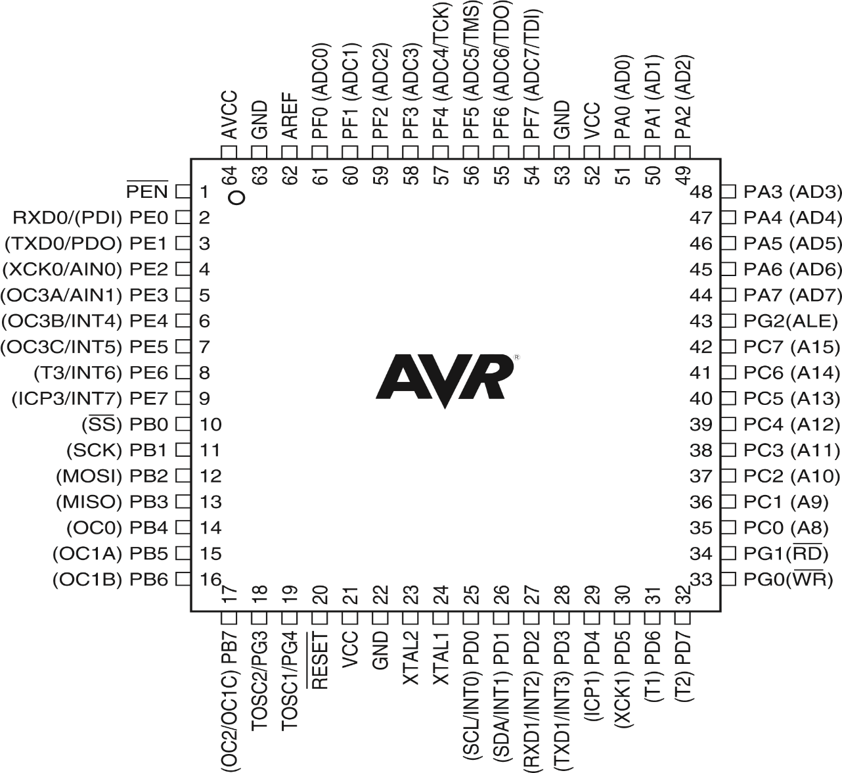

* Why choosing this microcontroller?

**Features:**

* High-performance, Low-power Atmel®AVR®8-bit Microcontroller
* Advanced RISC Architecture

– 32 x 8 General Purpose Working Registers + Peripheral Control Registers

– Fully Static Operation

– Up to 16MIPS Throughput at 16MHz

* High Endurance Non-volatile Memory segments

– 128Kbytes of In-System Self-programmable Flash program memory

– 4Kbytes EEPROM

– 4Kbytes Internal SRAM

– Write/Erase cycles: 10,000 Flash/100,000 EEPROM

– Data retention: 20 years at 85°C/100 years at 25°C (1)

– Optional Boot Code Section with Independent Lock Bits

– Up to 64Kbytes Optional External Memory Space

– Programming Lock for Software Security

– SPI Interface for In-System Programming

* JTAG (IEEE std. 1149.1 Compliant) Interface

– Boundary-scan Capabilities According to the JTAG Standard

– Extensive On-chip Debug Support

– Programming of Flash, EEPROM, Fuses and Lock Bits through the JTAG Interface

* Peripheral Features

– Two 8-bit Timer/Counters with Separate Prescalers and Compare Modes

– Two Expanded 16-bit Timer/Counters with Separate Prescaler, Compare Mode and Capture Mode

– Real Time Counter with Separate Oscillator

– Two 8-bit PWM Channels

– 6 PWM Channels with Programmable Resolution from 2 to 16 Bits

– Output Compare Modulator

– 8-channel, 10-bit ADC

* 8 Single-ended Channels
* 7 Differential Channels
* 2 Differential Channels with Programmable Gain at 1x, 10x, or 200x

– Byte-oriented Two-wire Serial Interface

– Dual Programmable Serial USARTs

– Master/Slave SPI Serial Interface

– Programmable Watchdog Timer with On-chip Oscillator

– On-chip Analog Comparator

* Special Microcontroller Features

– Power-on Reset and Programmable Brown-out Detection

– Internal Calibrated RC Oscillator

– External and Internal Interrupt Sources

– Six Sleep Modes: Idle, ADC Noise Reduction, Power-save, Power-down, Standby, and Extended Standby

– Software Selectable Clock Frequency

– ATmega103 Compatibility Mode Selected by a Fuse

– Global Pull-up Disable

* I/O and Packages

– 53 Programmable I/O Lines

– 64-lead TQFP and 64-pad QFN/MLF

* Operating Voltages

– 4.5 - 5.5V ATmega128

* Speed Grades

– 0 - 16MHz ATmega128

### 3.3.2 USBasp

* Overview

USBasp is a USB in-circuit programmer for Atmel AVR controllers. It simply consists of an ATMega8 and a few passive components. The programmer uses a firmware-only USB driver, no special USB controller is needed.

* Some of the key features include
* Works under multiple platforms. Linux, Mac OS X and Windows are tested.
* Programming speed is up to 5kBytes/sec.

Slow SCK option to support targets with low clock speed (< 1.5MHz).

* **Layout**

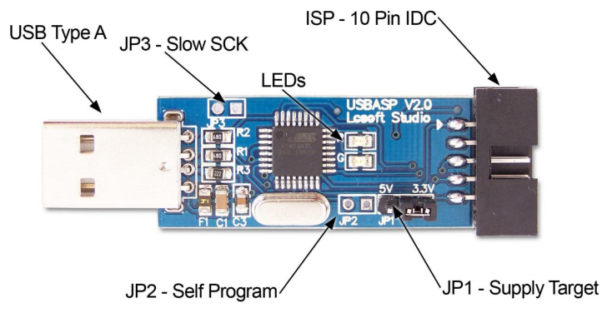**USB Type A**

The USB end of the programmer connects directly into your computers USB port.

* **ISP – 10 pin IDC**
* The 10 pin ISP connection provides an interface to the microcontroller. This interface uses a

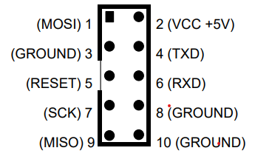10 pin IDC connector and the pinout

* **JP1 – Supply Target**

This jumper controls the voltage on the ISP VCC connector. It can be set to +3.3V, +5V or disable this jumper if the target device has its own power source.

* **JP2 – Self Program**

This jumper is used to update the firmware of the USBasp programmer. In order to update the firmware, you will need 2 programmers. One to be programmed and the other to do the programming.

* **JP3 – Slow SCK**

When this jumper is selected, the slow clock mode is enabled. If the target clock is lower than 1.5 MHz, you need to set this jumper. Then SCK is scaled down from 375 kHz to about 8 kHz.

* **LEDs**

The USBASP programmer has 2 LEDs near the ISP connection. These have the following functions:

LED R – Programmer communicating with target device

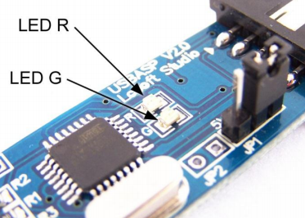LED G – Power

Whilst you might assume that LED R is red and LED G is green, they do vary depending on the batch. The one I use for instance has 2 red LEDs.

* 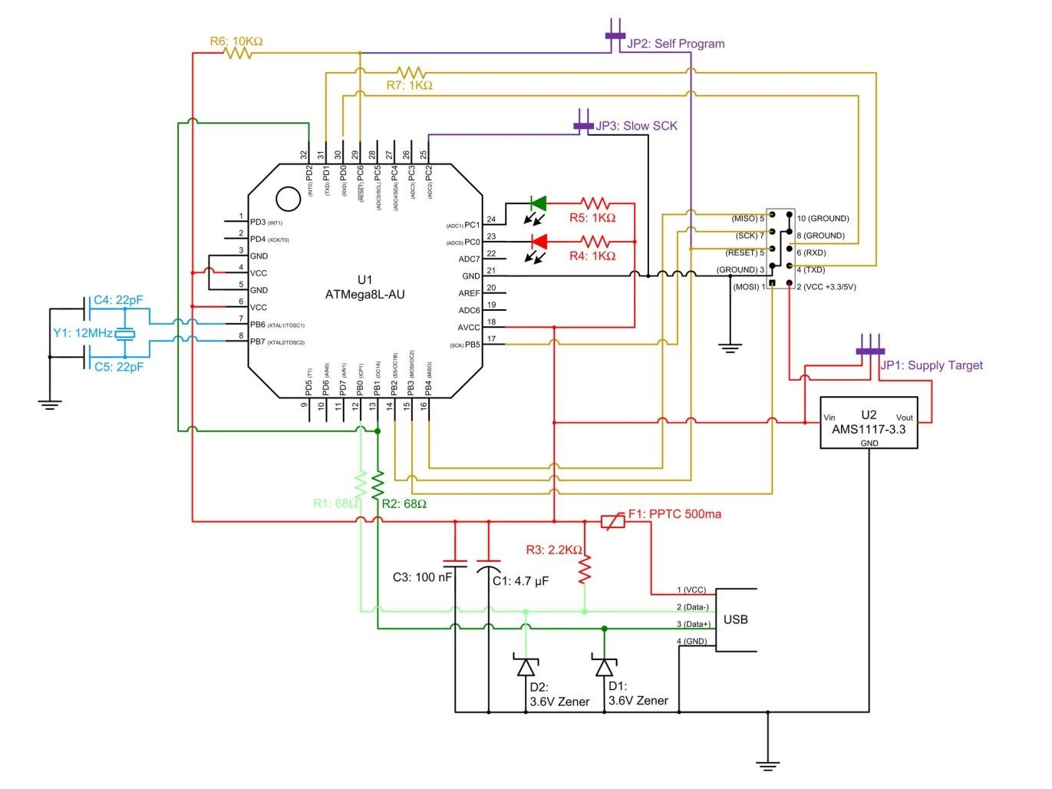**Circuit Diagram**

### 3.3.3 TTL (Serial to USB communication)

[**CP2102**](https://www.silabs.com/interface/usb-bridges/classic/device.cp2102) chip from SiLabs is a single chip USB to UART bridge IC. It requires minimal external components. CP2102 can be used to migrate legacy serial port based devices to USB. Hobbyists can use it as a powerful tool to make all kinds of PC interfaced projects.

* **Working**

This is an USB2.0 to TTL UART Converter module which is based on CP2102 Bridge by SiLabs. This module can be used with Laptop's which don't have standard serial port. This module creates a virtual COM port using USB on your computer which can support various standard Baud Rates for serial communication. You just need to install the driver using a setup file which automatically installs correct driver files for Windows XP/Vista/ 7. After driver installation, plug the module into any USB port of your PC. Finally a new COM port is made available to the PC. The feature which makes it more convenient is the TTL level data i/o. So you don't need to make a RS232 to TTL converter using chips like MAX232. The Rx and Tx pin can be connected directly to the MCUs pins (assuming 5v i/o).

* **Pinouts**

This module has 6 pin breakout which includes

* TXD = Transmit Output - Connect to Receive Pin(RXD) of Micro controller. This pin is TX pin of CP2102 on board.
* RXD = Receive Input - Connect to Transmit Pin(TXD) of Micro controller. This pin is RX pin of CP2102 on board.
* GND = Should be common to microcontroller ground.
* 3V3 = Optional output to power external circuit upto 50mA.
* 5V = Optional output to power external circuit upto 500mA
* 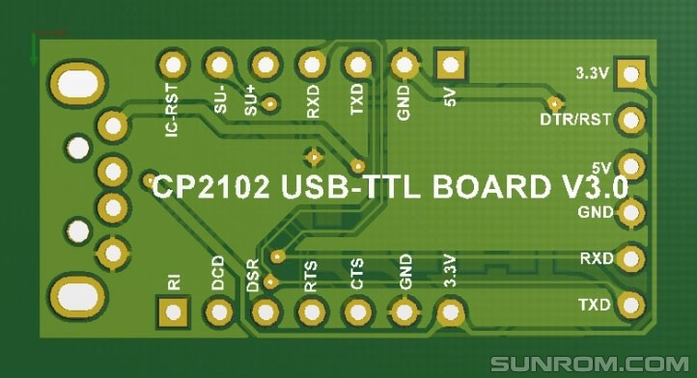DTR/RST = Optional output pin to reset external microcontrollers like Arduino.

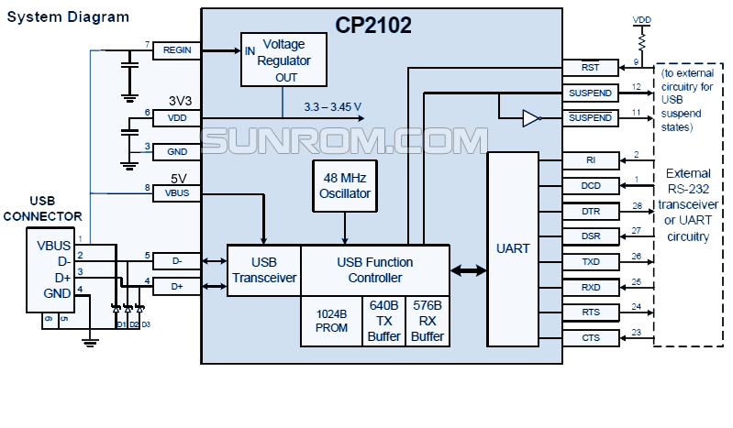

High Quality USB to TTL converter, comes with a 4-pin extension cable.

**Features:**

* Stable and reliable chipset CP2102.
* USB specification 2.0 compliant with full-speed 12Mbps.
* Standard USB type A male and TTL 6pin connector.
* 6pins for 3.3V, RST, TXD, RXD, GND & 5V.
* All handshaking and modem interface signals.
* Baud rates: 300 bps to 1.5 Mbps.
* Byte receive buffer; 640 byte transmit buffer.
* Hardware or X-On/X-Off handshaking supported.
* Event character support Line break transmission.
* USB suspend states supported via SUSPEND pins.
* Temperature Range: -40 to +85.
* Size: 42mm X 15mm.